Noise Diodes, Calibration, Baselines and Nonlinearities

¹Hynes, S.F., ²Maddalena, R., ³Figura, C.
¹Louisiana School for Math, Science and the Arts, Natchitoches, LA. shynes@lsmsa.edu
²National Radio Astronomy Observatory, Green Bank, WV. rmaddale@nrao.edu
³Wartburg College, Waverly, IA. charles.figura@wartburg.edu

I. Abstract

Data obtained by Johnson et al.¹ implied that the signal processing components of the GBT show nonlinearities, in that power measured by the system exhibits at least a quadratic dependence on the power incident on the antenna. Data taken in June and July 2006 confirms the original findings. The new data shows that compensating for the nonlinearity provides better baselines, that the nonlinearity is consistent over a typical run, and that the system calibration can be restored after adding and subtracting attenuation to the back-end components. The data also indicates that the nonlinearity is dependent on signal strength, and that each polarization can have different nonlinear characteristics.

II. Current Theory and Practice

The current radio source calibration technique assumes T_{cal}, the noise diode temperature, is constant over an 800 MHz bandwidth, hereafter referred to as IF. T_{cal} is averaged over the IF and then applied to the entire source signal within the same IF. Thus C-Band, with a range of 4-6 GHz, is broken down into 4 IF’s, 0 through 3, and a T_{cal} value is calculated for each IF.

T_{cal} is calculated by

$$T_{\text{cal}}=\left(\frac{{\text{Ref}}_{\text{on}}−{\text{Ref}}_{\text{off}}}{{\text{Sig}}_{\text{off}}−{\text{Ref}}_{\text{off}}}\right)T_{A}$$ | (1)

where
η = Efficiency | θ = Elevation (radians)
A_{p} = Area of the telescope (m²) | Sig_{on} = On source, noise diode on
k = Boltzman’s constant (J/K) | Sig_{off} = On source, noise diode off
S(ν) = Source Flux (Jy) | Ref_{on} = Off source, noise diode on
τ = Opacity | Ref_{off} = Off source, noise diode off

If η is not known, it can be calculated through the use of a laboratory-measured value for T_{cal} by
$$η=\frac{{\text{2kT}}_{\text{cal}}^{\text{eng}}}{A_{p}S_{\text{cal}}^{\text{astro}}}$$ | (2)
T_{cal} is then used to calculate the system temperature, T_{sys}. Traditionally, T_{sys} has been averaged over all channels to improve the signal-to-noise ratio. The GBT is different in that it has 4096 channels, hence the reason for the averaging over an 800 MHz bandwidth. Earlier telescope spectrometers have far fewer channels, thus the averaging is done over all of them. The system temperature T_{sys} and the antenna temperature T_{A} may then be determined.

$$\begin{aligned}T_{\text{sys}}+\frac{T_{\text{cal}}}{2}={\left\langle \frac{\text{Ref}\left(ν\right)}{{\text{Ref}}_{\text{on}}\left(ν\right)−{\text{Ref}}_{\text{off}}\left(ν\right)}T_{\text{cal}}\right\rangle }_{ν} \\ \\ T_{A}\left(ν\right)=\frac{\text{Sig}\left(ν\right)−\text{Ref}\left(ν\right)}{\text{Ref}\left(ν\right)}{\left\langle \frac{\text{Ref}\left(ν\right)}{{\text{Ref}}_{\text{on}}\left(ν\right)−{\text{Ref}}_{\text{off}}\left(ν\right)}T_{\text{cal}}\right\rangle }_{ν}\end{aligned}$$ | (3)  (4)

where
$$\begin{aligned}\text{Ref}\left(ν\right)=\frac{{\text{Ref}}_{\text{on}}+{\text{Ref}}_{\text{off}}}{2}⇒\left[T_{\text{CMB}}+T_{\text{spill}}+T_{\text{atm}}\right]+\left[T_{\text{rcvr}}\left(ν\right)+\frac{T_{\text{cal}}\left(ν\right)}{2}\right] \\ \\ \text{Sig}\left(ν\right)=\frac{{\text{Sig}}_{\text{on}}+{\text{Sig}}_{\text{off}}}{2}⇒\left[T_{\text{CMB}}+T_{\text{spill}}+T_{\text{atm}}+T_{\text{src}}\right]+\left[T_{\text{rcvr}}\left(ν\right)+\frac{T_{\text{cal}}\left(ν\right)}{2}\right]\end{aligned}$$ | (5)  (6)

The result of the averaging is still the same in that the receiver and associated systems loses any frequency-dependent behavior.

The frequency dependence of T_{A} comes from the variables Sig(ν) and Ref(ν). The right hand sides of equations (5) and (6) illustrate the individual terms that contribute to the frequency dependence. Several of the component temperature terms are either constant or smoothly varying in frequency (cosmic microwave background, ground spillover, and atmosphere) while others (receiver & associated equipment and calibration source) show sharper frequency variation.

III. Baselines

As mentioned above, the GBT is unique in that the spectrometer has 4096 channels, providing finer frequency resolution of all measurements as compared to previous telescopes. This introduces the problem that averaging T_{cal} over an IF does not provide an accurate baseline, except at the median of a given IF.

To provide a better baseline, it was proposed by Johnson, et al.² that T_{cal} not be averaged over a given IF, but should instead retain the frequency-dependence. This requires an assumption that all the electronic signal processing components of the telescope operate in the linear region of the power in vs. power out graph shown below.

Figure 1: Power in vs. Power out. The points on the graph represent Ref_{off}, Ref_{on}, Sig_{off}, Sig_{on} from lowest to highest power in.

This means that there is a linear transfer of power through each piece of electronic equipment. The associated temperature equations then become:

$$\begin{aligned}T_{\text{sys}}\left(ν\right)=B_{o}\left({\text{Ref}}_{\text{off}}\left(ν\right)\right)+A \\ \\ T_{\text{sys}}\left(ν\right)+T_{\text{cal}}\left(ν\right)=B_{o}\left({\text{Ref}}_{\text{on}}\left(ν\right)\right)+A \\ \\ T_{\text{sys}}\left(ν\right)+T_{A}\left(ν\right)=B_{o}\left({\text{Sig}}_{\text{off}}\left(ν\right)\right)+A \\ \\ T_{\text{sys}}\left(ν\right)+T_{\text{cal}}\left(ν\right)+T_{A}\left(ν\right)=B_{o}\left({\text{Sig}}_{\text{on}}\left(ν\right)\right)+A\end{aligned}$$ | (7)  (8)  (9)  (10)

Where B is directly proportional to the gain of the system, and has units of K/count. It is important to note that A cannot be distinguished from T_{sys}, since both are additive and are present in each equation.
T_{A} now retains all frequency information as shown in the equations below.

$$\begin{aligned}T_{\text{sys}}\left(ν\right)+\frac{T_{\text{cal}}\left(ν\right)}{2}=\frac{\text{Ref}\left(ν\right)}{{\text{Ref}}_{\text{on}}\left(ν\right)−{\text{Ref}}_{\text{off}}\left(ν\right)}T_{\text{cal}}\left(ν\right) \\ \\ T_{A}\left(ν\right)=\frac{\text{Sig}\left(ν\right)−\text{Ref}\left(ν\right)}{{\text{Ref}}_{\text{on}}\left(ν\right)−{\text{Ref}}_{\text{off}}\left(ν\right)}T_{\text{cal}}\left(ν\right)\end{aligned}$$ | (11)  (12)

A comparison of antenna temperatures is shown in Figure 2. Indicated are the traditional form (using scalar T_{sys}), the idealized source temperature obtained from catalog values³ and the new T_{A} calculated from equation (12).

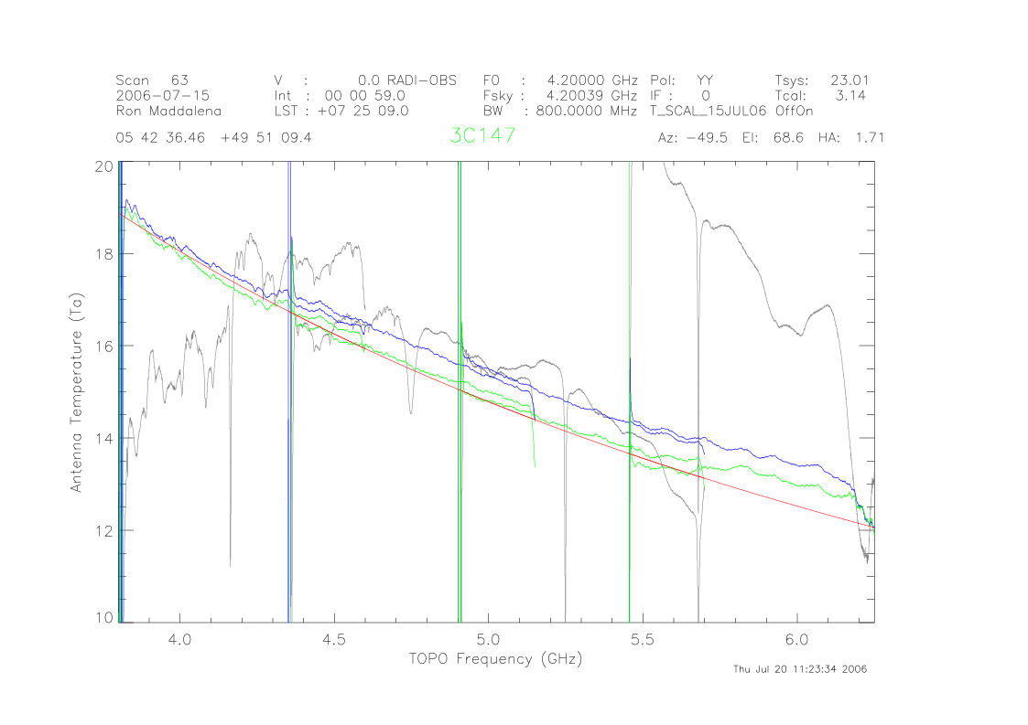
Figure 2: T_{A} vs. Frequency. T_{A} catalog is in Red, T_{A} linear is in Blue and T_{A} traditional is in Grey.
I would like to put the graph I mentioned in the email here instead of the one I have above.
Figure 2 demonstrates that by simply retaining the frequency dependence, baselines are greatly improved.

Nonlinearity

During the linear calibration study performed by Johnson, et al., a new quantity was defined called Resids¹.

$$\text{Resids}=\left({\text{Sig}}_{\text{on}}−{\text{Sig}}_{\text{off}}\right)−\left({\text{Ref}}_{\text{on}}−{\text{Ref}}_{\text{off}}\right)$$ | (13)

Figure 3: Resids vs. Power out.¹

Notice that if the power into the telescope is directly proportional to the power out of the telescope, then the quantity Resids as calculated in equation 13 should equal zero. However, as the graphs in Figure 3 suggest, this is not always the case. This is a clear indicator that the power measured by the GBT (frontend and backend) is not linear in power incident on the antenna. This was confirmed with a new set of data taken on June 18, 2006.

Figure 4: Resids vs. Power In. Data obtained June 18, 2006.

The data in Figure 4 suggests that at a minimum a second order term is necessary to properly model the power out vs. power in. Thus the linear region in Figure 1 is not truly linear, but is in fact a quadratic function. Figure 4 also suggests that the second order term is small, since the slope of Resids is approximately equal to 0.01. The data on the right-hand side of Figure 4 (corresponding to Virgo A) suggest that extended and/or high-flux sources do not follow the same gain curve.

So, we must include a second order correction for gain:
$P_{\text{out}}^{'}=P_{\text{out}}+\frac{C}{B}P_{\text{out}}^{2}$ | (14)

The quadratic temperature equations previously expressed as equations 7-10 then become:
$$\begin{aligned}T_{\text{sys}}={\text{Ref}}_{\text{off}}+\frac{C}{B}{\left({\text{Ref}}_{\text{off}}\right)}^{2} \\ T_{\text{sys}}+T_{\text{cal}}={\text{Ref}}_{\text{on}}+\frac{C}{B}{\left({\text{Ref}}_{\text{on}}\right)}^{2} \\ T_{\text{sys}}+T_{\text{source}}={\text{Sig}}_{\text{off}}+\frac{C}{B}{\left({\text{Sig}}_{\text{off}}\right)}^{2} \\ T_{\text{sys}}+T_{\text{cal}}+T_{\text{source}}={\text{Sig}}_{\text{on}}+\frac{C}{B}{\left({\text{Sig}}_{\text{on}}\right)}^{2}\end{aligned}$$ | (15)  (16)  (17)  (18)

Since there are 4 equations and four unknowns, analytic solutions for T_{sys}, T_{cal}, C, and B can be obtained. The solutions are shown below.
$\begin{aligned}T_{\text{cal}}=\frac{\left({\text{Ref}}_{\text{off}}−{\text{Ref}}_{\text{on}}\right)\left({\text{Ref}}_{\text{off}}+{\text{Ref}}_{\text{on}}−{\text{Sig}}_{\text{off}}−{\text{Sig}}_{\text{on}}\right)\left({\text{Sig}}_{\text{off}}−{\text{Sig}}_{\text{on}}\right)}{\left({\text{Ref}}_{\text{off}}−{\text{Sig}}_{\text{off}}\right)\left({\text{Ref}}_{\text{on}}−{\text{Sig}}_{\text{on}}\right)\left({\text{Ref}}_{\text{off}}−{\text{Ref}}_{\text{on}}+{\text{Sig}}_{\text{off}}−{\text{Sig}}_{\text{on}}\right)}T_{\text{src}} \\ \\ B^{\text{cal}}=\frac{\left({\text{-Ref}}_{\text{off}}^{2}+{\text{Ref}}_{\text{on}}^{2}+{\text{Sig}}_{\text{off}}^{2}−{\text{Sig}}_{\text{on}}^{2}\right)}{\left({\text{Ref}}_{\text{off}}−{\text{Sig}}_{\text{off}}\right)\left({\text{Ref}}_{\text{on}}−{\text{Sig}}_{\text{on}}\right)\left({\text{Ref}}_{\text{off}}−{\text{Ref}}_{\text{on}}+{\text{Sig}}_{\text{off}}−{\text{Sig}}_{\text{on}}\right)}T_{\text{src}} \\ \\ \text{C }=\frac{\left({\text{Ref}}_{\text{off}}−{\text{Ref}}_{\text{on}}−{\text{Sig}}_{\text{off}}−{\text{Sig}}_{\text{on}}\right)}{\left({\text{Ref}}_{\text{off}}−{\text{Sig}}_{\text{off}}\right)\left({\text{Ref}}_{\text{on}}−{\text{Sig}}_{\text{on}}\right)\left({\text{Ref}}_{\text{off}}−{\text{Ref}}_{\text{on}}+{\text{Sig}}_{\text{off}}−{\text{Sig}}_{\text{on}}\right)}T_{\text{src}} \\ \\ T_{\text{sys}}^{\text{cal}}=\frac{{\text{Ref}}_{\text{off}}\left({\text{Ref}}_{\text{on}}^{2}+{\text{Sig}}_{\text{off}}^{2}−{\text{Ref}}_{\text{off}}\left({\text{Ref}}_{\text{on}}+{\text{Sig}}_{\text{off}}−{\text{Sig}}_{\text{on}}\right)−{\text{Sig}}_{\text{on}}^{2}\right)}{\left({\text{Ref}}_{\text{off}}−{\text{Sig}}_{\text{off}}\right)\left({\text{Ref}}_{\text{on}}−{\text{Sig}}_{\text{on}}\right)\left({\text{Ref}}_{\text{off}}−{\text{Ref}}_{\text{on}}+{\text{Sig}}_{\text{off}}−{\text{Sig}}_{\text{on}}\right)}T_{\text{src}}\end{aligned}$ | (19)  (20)  (21)  (22)

To apply the new nonlinear equations, T_{cal}, C, and B are determined using a known calibration source whose apparent size is much smaller than the antenna beamwidth. These quantities can then be used in the linear expression (equation 12) to calculate T_{A}. This equation can again be used for the nonlinear case since the nonlinearity is encapsulated in P’_{out}, defined in equation (14).

Figure 5 shows 3 T_{A} variations over all IF’s. Notice that over a short time scale, the calibration data was taken a few minutes before the source data, all the graphs follow closely. However, further analysis determined that the nonlinear T_{A} exhibits a closer match to the catalog source temperature than the linearly-calculated value in many, but not all cases.
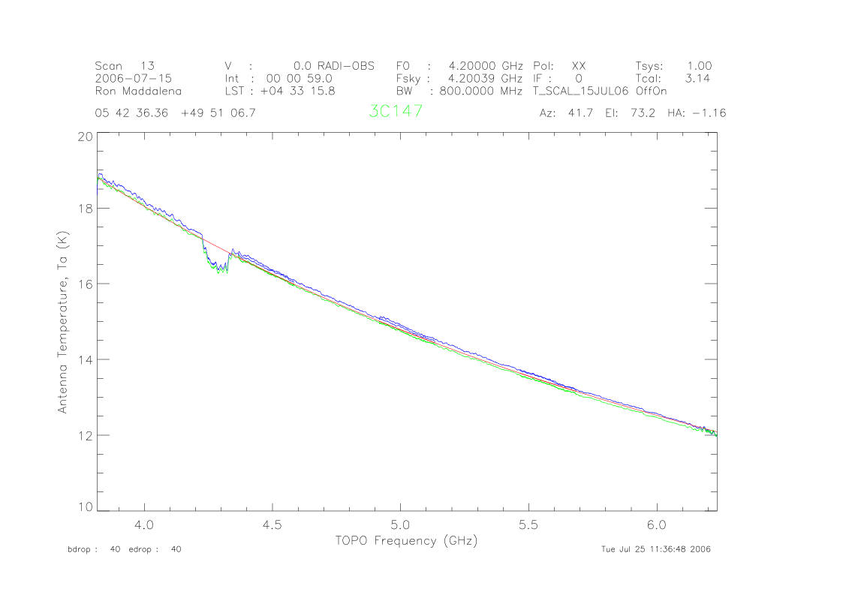
Figure 5: T_{A} vs. Frequency. T_{A} catalog is in Red, T_{A} linear is in Blue, and T_{A} nonlinear is in Green.

IV. Analysis

- Time Dependence

The issue now becomes whether the nonlinearity as characterized by the parameter C/B in equations (14) through (18) holds over time. Figure 5 represents time t = 0 hours, where the calibration data was taken approximately 5 minutes before the source data, and progressing through Figures 6 through 8, illustrating 2 hours, 4 hours, and then 1 month between the calibration data and the source data. The calibration does well over short time periods (0 to 4 hours) exhibiting a 5% variation at high frequencies at 4 hours (Figure 7), and approximately the same % variation over a month (adding the variation from Figure 6 and Figure 8). The variation between linear, nonlinear, and the catalog values of T_{A} increases from 0 hours to 4 hours, and then levels off to a value of approximately 5%. The drift is less at the low frequency end, and the reason for this is unknown.
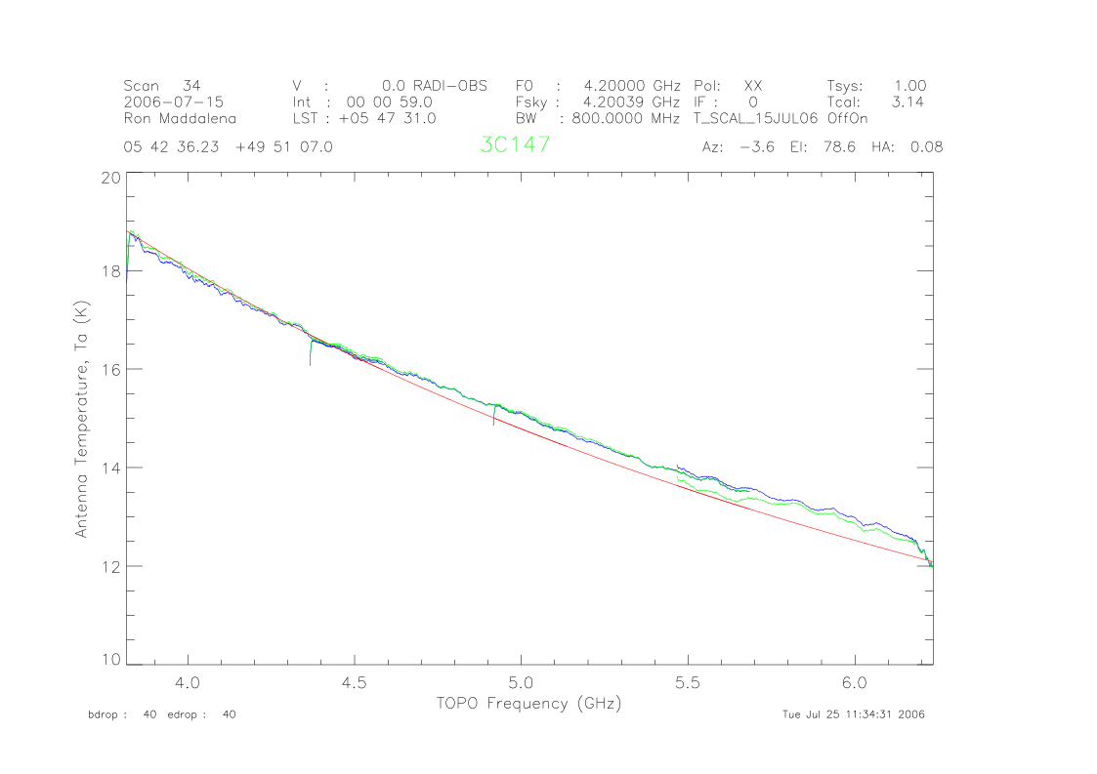
Figure 6: T_{A} vs. Frequency. Time t = 2 hours. T_{A} catalog is in Red, T_{A} linear is in Blue, and T_{A} nonlinear is in Green.
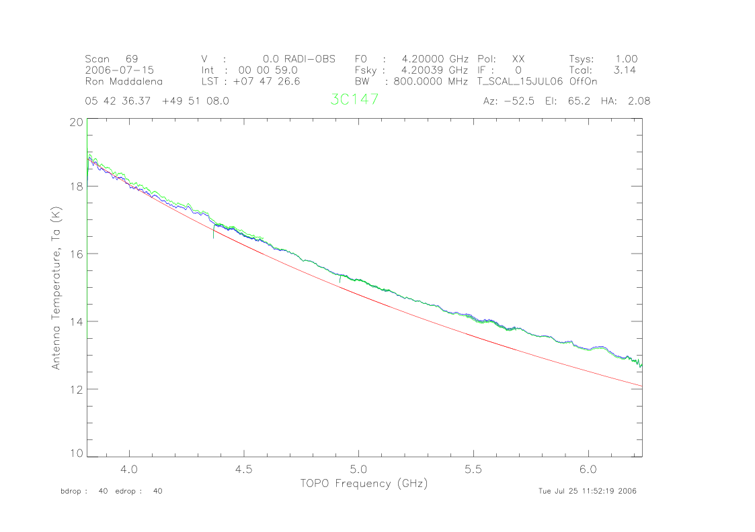
Figure 7: T_{A} vs. Frequency. Time t = 4 hours. T_{A} catalog is in Red, T_{A} linear is in Blue, and T_{A} nonlinear is in Green.

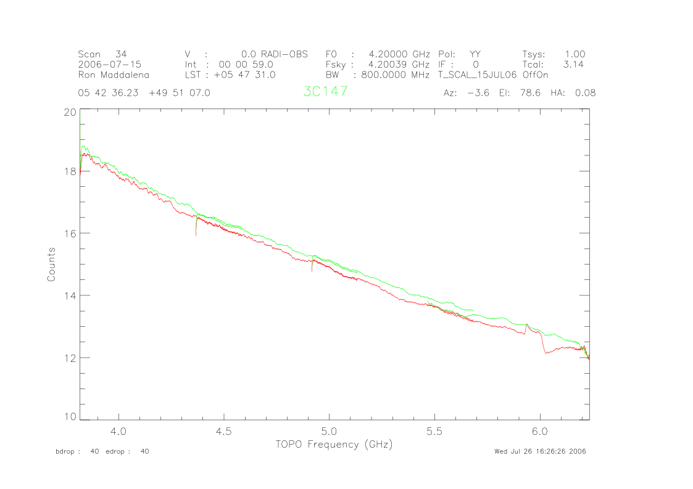

Figure 8: T_{A} vs. Frequency. This graph has the T_{A} nonlinear at t = 2 hours, shown in Green, and the T_{A} nonlinear at t = 1 month, shown in Red.

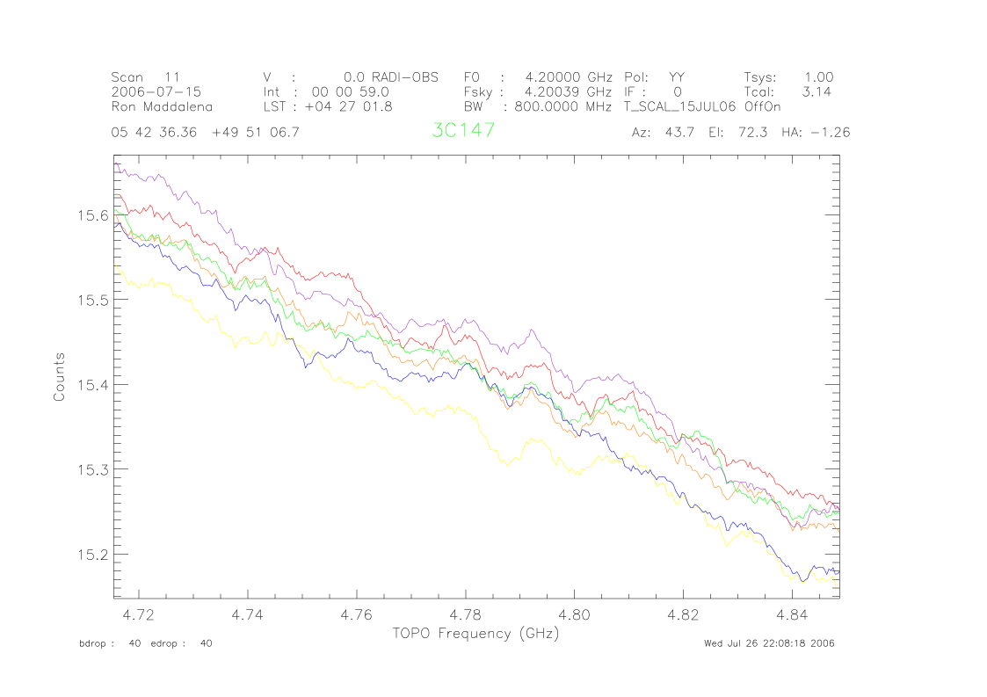
Figure 9: T_{A} over time. Red represents t = 0 hours, Violet represents t = 2 hours.

Antenna temperatures were also compared over 2 and 4 hour spreads. Figure 9 represents T_{A} over a two hour stretch. Red represents time t = 0 hours and violet represents time t = 2 hours with increased time progressing chromatically from red to violet. Notice that there appears to be no pattern with respect to time for the variation of T_{A}. This indicates that over 2 hours, T_{A} remains stable, and that any variation is random.
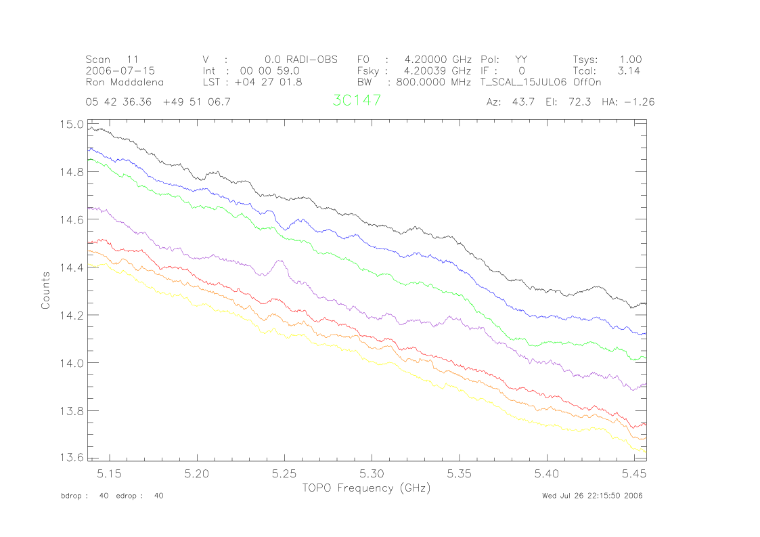
Figure 10: T_{A} over Time. Red represents t = 0 hours and Black represents t = 4 hours.

Figure 10 shows T_{A} over 4 hours. There does appear to be a non-random drift over time, indicating that T_{A} does change over a 4 hour period.

B. System Characterization

During the July 15, 2006 GBT run, attenuation was added and subtracted at various locations (at IF and converter racks) in an effort to characterize each electronic component from the receiver to the spectrometer.

There were several variations of attenuation. Figure 11 illustrates how the nonlinearity of the system (as characterized by the quantity C) decreases when attenuation is subtracted from the system, thus increasing the power output.

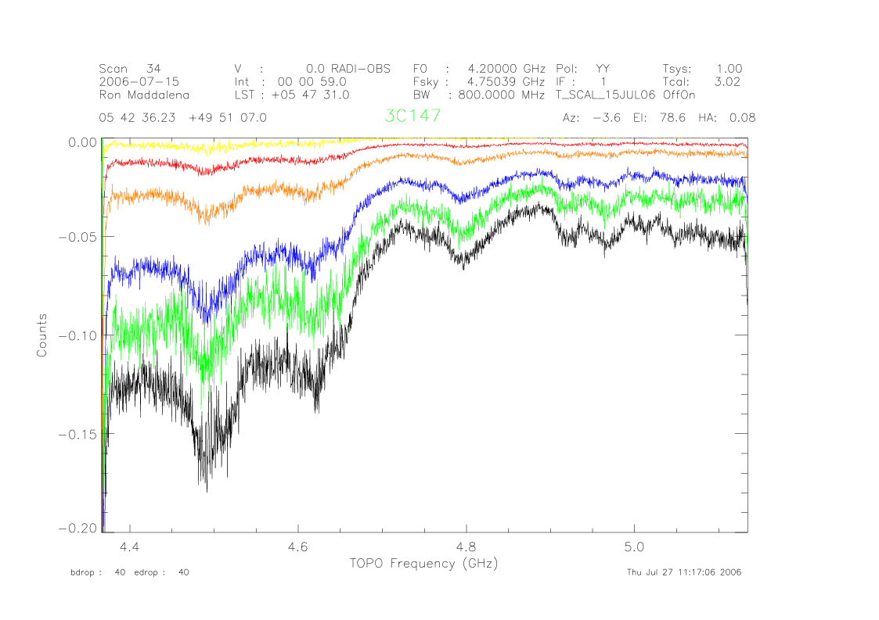
Figure 11: C as a function of frequency. IF represents attenuation subtracted from the IF Rack, CR represents attenuation subtracted from the Converter Rack, and IFR represents attenuation subtracted from the IF Rack, but with the spectrometer rebalanced.
-3dB (IF)
-6dB (IFR)
-6dB (CR)
-6dB (IF)
-10dB (IF)
No Attenuation

Figure 11 shows that as more attenuation is subtracted from the system the nonlinearity, directly measured by the coefficient ‘C’, decreases, indicating that the nonlinearity decreases. This suggests that as you approach the upper end of the power in vs. power out graph (Figure 1), the nonlinearity decreases, or possibly parts of the system enter a compression state; therefore the expansion and compression effects are canceling, mimicking a linear relationship.

Figure 12 is a graph of C as a function of frequency when attenuation is added to the system. Although Figure 11 and 12 are not to the same scale, the curve representing no attenuation is the same on each graph (black line). Where Figure 11 showed an improvement in the nonlinearity, Figure 12 shows that as attenuation is added to the system, resulting in a decrease in overall power, nonlinearity increases. Therefore, sources requiring high attenuation will be subjected to greater nonlinearity affects from the system, and that the expansive nonlinearity characteristics of all the receiver and associated equipment increases as power decreases.

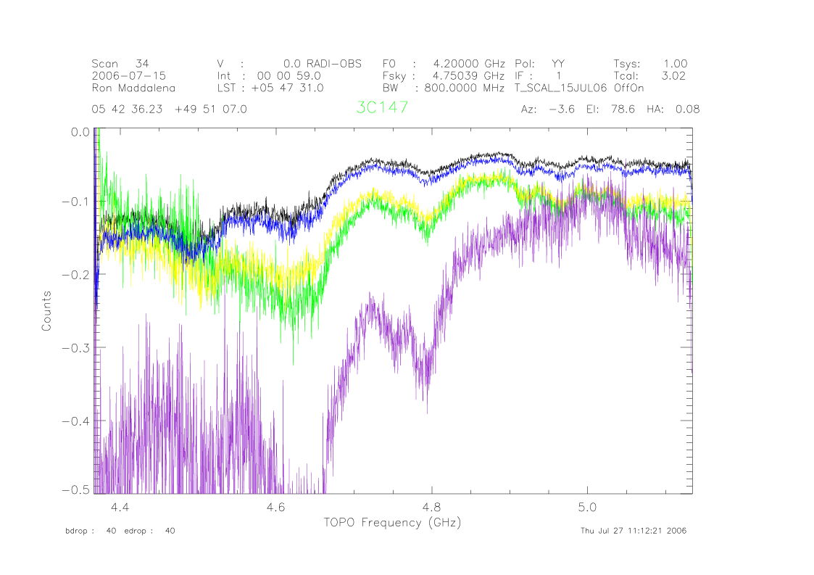
+3dB (IF)
+6dB (CR)
+6dB (IF)
+10dB (IFR)
+10dB (IF)
No attenuation
Figure 12: C as a function of frequency. IF represents attenuation added from the IF Rack, CR represents attenuation added from the Converter Rack, and IFR represents attenuation added from the IF Rack, but with the spectrometer rebalanced.

C. Attenuation effects on Baselines

The following graphs illustrate how the linear and nonlinear baseline graphs are affected by attenuation as compared to the logarithmic baseline.

Figure 13 shows 3dB of attenuation subtracted from the IF Rack. Both the linear and nonlinear baselines show distortions, although the nonlinear baseline fits the catalog baseline better than the linear.

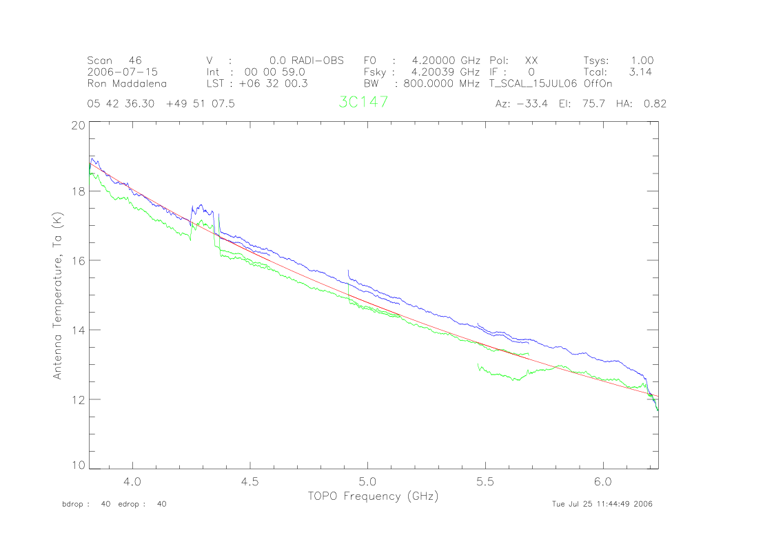
Figure 13: T_{A} vs. Frequency, -3dB of attenuation at the IF Rack. The nonlinear baseline is in Green, the linear baseline is in Blue, and the catalog baseline is in Red.
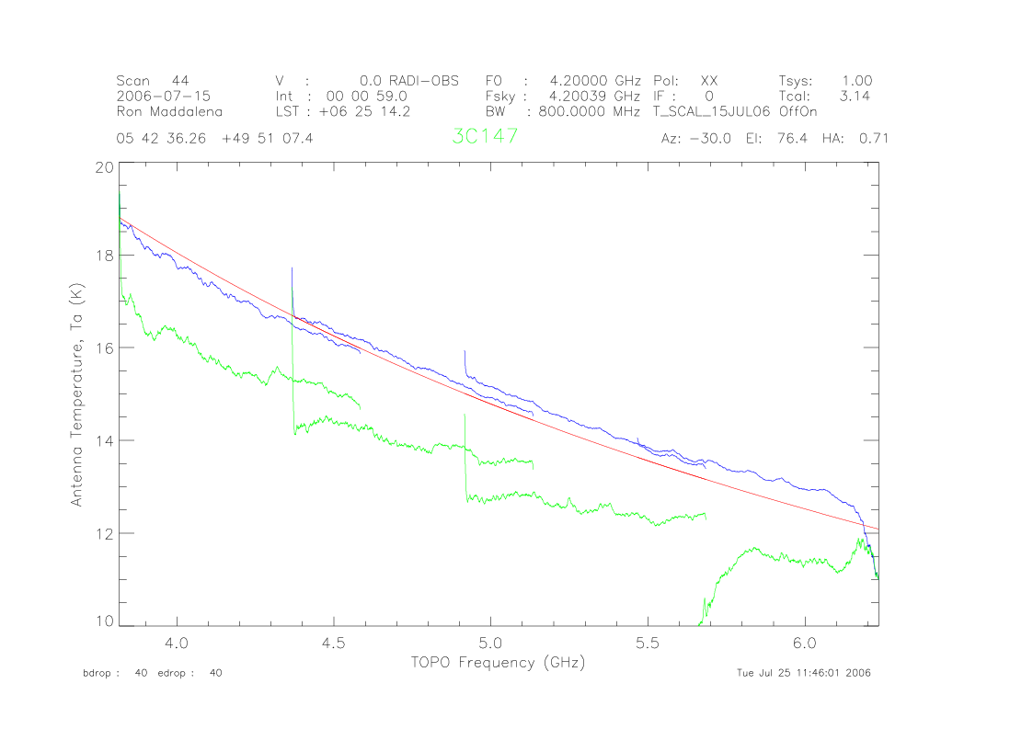

Figure 14: T_{A} vs. Frequency. -6dB of attenuation at the IF Rack. The nonlinear baseline is in Green, the linear baseline is in Blue, and the catalog baseline is in Red.
Figure 14 represents 6dB subtracted from the IF rack. In this case, the nonlinear baseline is far removed from the linear and catalog, suggesting that the nonlinearity does not hold for high output power. This is consistent with the data in Figure 11, suggesting that the previously-determined nonlinear coefficients are not appropriate for high power.

Figure 15 is T_{A} vs. frequency but the system has been rebalanced. Figure 15 is encouraging in that large variations in the system do not greatly affect the consistency of the nonlinearity. However, it is important to note that the nonlinearity has changed by approximately 5% at the high frequency end.
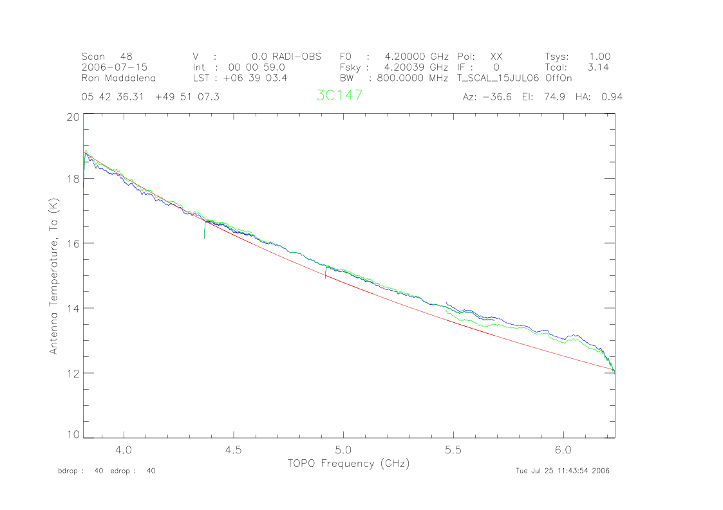
Figure 15: T_{A} vs. Frequency, system rebalanced. This graph shows how the baselines have changed after attenuation was added and subtracted, and then the system was rebalanced.

V. Conclusions and Recommendations

The data implies that each signal processing component of the GBT system shows some form of nonlinearity, from the receiver to the spectral processor. While each component's nonlinear characteristics are unique, the system can be modeled as a whole provided that the system characteristics are not significantly altered for the duration of an observation.

The data also suggests that at a minimum the vector form of T_{cal} should be used for baselines over the traditional T_{cal}, regardless of linear or non-linear assumptions. Once the vector form is implemented, baselines are slightly improved by the quadratic approximation, but for many observations the linear form of T_{cal} is sufficient. Low power, reliable point sources provide the most consistent calibrations.

If the system becomes highly attenuated, either positively or negatively, the data shows that the baselines are affected, however rebalancing the system does restore the original nonlinearity. This suggests that rebalancing often would be helpful in maintaining the original nonlinearity, but this has not been observed, and in a few cases the opposite was true. Balancing often could cause C to change. High power sources such as Virgo A mimic negatively attenuated equipment, and exhibit similar effects but the reason for this is most likely that high power sources require higher order terms as suggested by Figure 4. Extended sources, often with high power output, also show some of the same characteristics. These types of sources could possibly be compensated for, but that has yet to be determined. Polarized sources, when averaged, showed consistent results. However, averaging the two polarizations is undesirable since much information is lost in the process. In conclusion, high power, extended, and polarized sources should not be used as calibrators.

In summary, the receiver and associated equipment clearly demonstrates nonlinear properties that can be modeled. For many astronomers who require accurate baselines, including the nonlinear approximation will greatly benefit their work. For most astronomers, simply maintaining the vector information in the baseline will provide better results.

VI. References

¹ Johnson, C., Maddalena, R., Personal Communication. 2005.

² Johnson, Maddalena, Ghigo, Balser. Comparison of Engineer’s and Astronomical
Noise Diode Values for Four Receivers. Internal Memo, NRAO, Green Bank, WV.
December 3, 2002.

³ Ott, M., Witzel, A., Quirrenbach, A.,Krichbaum, T.P., Standke, K.J., Schalinski, C.J., Hummel, C.A. An updated list of radio flux density calibrators. Astron. Astrophysics. 61, 99. 1993.

⁴ Baars, J.W.M. The Measurement of Large Antennas with Cosmic Radio Sources. IEEE Trans. Antennas & Propagation. AP-21, 4. July 1973.

