Quiet Skies Curriculum Outline:

Goals for students:
Through Quiet Skies, students will:
- Measure interference levels at their schools and in their communities
- Reduce their data and submit them to an NRAO data base;
- Use online spectrum allocation data and local information to determine possible causes of interference in their area;
- Contemplate the complex trade-offs between radio astronomy’s need for quiet skies, and other commercial and non-commercial uses of the spectrum, and share their insights with others.

The curriculum loosely models the learning cycle, and culminates in students conducting Quiet Skies experiments and uploading data to our website.

I. Introduction--What is Radio Astronomy?

Engage: Electromagnetic Spectrum Chart activity
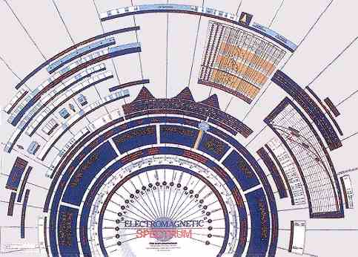
This inquiry activity makes use of the detailed EM Spectrum Chart included in the kit. Question posed to pairs or trios of students: “What are ALL of the things you notice about the EM spectrum?” Student teams study and discuss the chart and write down some observations. Give them time to really dig into the chart!

After responses are shared, then ask: “What are ALL of the questions you have?” Students share their questions and this list will serve as a foundation for the rest of the activities in the unit.

Our favorite chart for this activity is the one produced by the Exploratorium. The kit contains a set of five of these for classroom use. Another good, free one is http://www.tufts.edu/as/wright_center/products/svl/posters/ems.html.

Explore: Seeing the invisible.
Students map heat on top of a cookie sheet and produce a false color image. The activity was developed by the Astronomical Society of the Pacific. You'll need a cookie sheet, colored squares of felt, and an ice cube and hand warmer heat source. The detector in the activity is your skin rather than your eyes. Core Concept: Not all forms of EM energy are visible, but they can all be detected. Astronomers want to study all of the energy that comes to us from the universe, not just visible light! The activity is described at http://www.gb.nrao.edu/epo/RedHotBlueHot.pdf.

Explain: Multi-wavelength tour of the constellation of Orion.
Students will learn that scientists study cosmic objects in all parts of the EM spectrum. A web tour features images and descriptions of Orion at visible, infrared and radio wavelengths. (http://www.gb.nrao.edu/epo/OrionTour/)

Elaborate: Radio Astronomy: The story of science, technology and the noisy world we live in.
An annotated power point gives a fairly complete overview of the radio universe and introduces the concept of Radio Frequency Interference (RFI). (http://www.gb.nrao.edu/epo/powerpoint/ppt.html)
II. What is RFI?

Engage: Be an Interference Detective.
The activity introduces RFI by engaging students in finding sources of it! The activity uses AM radios to detect interference all over the school! (http://www.gb.nrao.edu/php/quietskies/activity.html)

Explore: Who uses the radio spectrum?
Students will conduct an inquiry-based exploration of the radio spectrum using the US Spectrum Allocation Charts provided in your kits (for an online version, see http://www.ntia.doc.gov/osmhome/Allochrt.html )

Introduce the activity with: “The AM radios detect quite a lot of RFI— but only at frequencies below 1,600 kilohertz (1.6 megahertz). Radio telescopes typically study the universe over a range of frequencies from 30 MHz to 300 GHz. Are our skies free from RFI at these frequencies? Use the FCC spectrum allocation charts to find out.” You can assign parts of the chart to different groups.

Extend: Introduce the students to the Quiet Skies detectors and how they operate.
The manual is located at: http://www.gb.nrao.edu/php/quietskies/manual.pdf. Go on a fox hunt! Hide the 800 MHz transmitter (included in the kit) and challenge students to find it. Once they find the tramsmitter, switch to narrow band mode and tune to determine the exact transmitting frequency.

III. Are Your Skies Quiet?
Finally, we reach our goal: Measuring RFI using the Quiet Skies Detectors. The detectors measure RFI between 800 and 1700 MHz—a range of frequencies many radio telescopes detect. Students should design an experiment to measure RFI and report it back to the NRAO. Example questions to investigate: Does RFI change with time of day? Do RFI levels change with cardinal direction? Do RFI levels change with frequency? Students report back to the NRAO the location and time of their measurements, and the frequency, intensity, and direction of the RFI.

If students detect RFI at a particular frequency and in a certain direction, what could it be? Students can search for fixed licensed transmitters on the FFC website.
- Visit http://wireless.fcc.gov/uls
- Click on “search licenses”
- Click on “geographic” under specialized searches.
- Then enter your location, a radius about which you want to search, a frequency range, etc.
- You’ll see a list of transmitters. By clicking on them students can learn exactly where they are, what frequency they radiate, even what they are for!
Or try http://www.cellreception.com/towers to look for cell phone towers in the area:

IV. Capstone Debate:
Can radio astronomy co-exist with increasing commercial pressure on the spectrum? What are the tradeoffs? In Green Bank, WV, people go without cell phones so that radio astronomy can be done. What do you think of that?

Other resources:
1. Webquest missions that focus on particular frequencies of interest to astronomers. See our mission pages for pulsars (http://www.gb.nrao.edu/php/quietskies/pulsars.html), interstellar hydrogen (http://www.gb.nrao.edu/php/quietskies/hydrogen.html), and star formation (http://www.gb.nrao.edu/php/quietskies/HII.html).
2. Learn more about the National Radio Quiet Zone at http://www.gb.nrao.edu/nrqz/nrqz.shtml.

