GBT Commissioning memo 19:
RFI survey at S-Band (1.7-2.6 GHz)
.
F. Ghigo (Feb.25, 2002)

Summary
Surveys for interference were done with the GBT 2-3 GHz receiver in two sessions, one on January 30-31, 2002, the second on February 7-8, 2002. On both occasions the same procedure was followed. Data were acquired with the GBT pointed at four different azimuths (az = 6, 96, 186, and 276 degrees), all at an elevation of 55 degrees. Linear polarization was used, and the Spectral Processor acquired the data. The laser power and computer systems were on for the first session, and off for the second.
Several strong RFI signals appeared in the second session that had not occurred the previous week, when the laser systems were on. Signals at some of the same frequencies as the previous week appear at drastically different power levels. In view of the apparent variable nature of many of the sources of RFI, we cannot definitely associate any signals with the laser systems.
Very strong and variable RFI from a satellite is seen between 2320 and 2346 MHz. This part of the band is essentially unusable. The 2487-2500 MHz RFI may also be due to a satellite. A summary of the strongest RFI components is given in Table 1.
Several signals are strongest in the general direction of the Jansky Lab; of particular note are signals at 2200 and ~2467 MHz.
Table 1. Strong RFI, 1.7-2.6 GHz
F(MHz) | Peak power (db) | HP width (MHz) | Comments
1814.6 | 0.9 | 0.05
1844.0 | 1.4 | 1.0
2118.0 | 1.8 | 0.8
2285-2292 | 1.0 | 5.0
2320-2345 | 15.3 | 6.0 | Satellite Digital Audio Radio Services
2361.5 | 1.2 | 1.0
2460-2470 | 1.0 | 1.0
2487-2498 | 4.0 | 5.0 | Non Geostationary Mobile Satellite Service?
2561.3 | 0.8 | 1.0
Note: Column 2 is the approximate peak relative to the baseline, i.e., relative to the system temperature.

Observations
To cover the whole band from 1.68 to 2.65 GHz using the Spectral Processor, which has a maximum bandwidth of 40 MHz, a series of 28 scans was done spaced at 35 MHz intervals. The lowest band center was 1695 MHz, and the highest was 2640 MHz. A two-minute integration was done at each frequency. The sequence took about an hour.
Each band center was converted to an IF at 6 GHz, and the 80 MHz IF filter was used, centered at 6 GHz. This IF was converted to 250 MHz for input to the Spectral Processor.
We experimented with the azimuth positioning of the GBT to find the azimuth that pointed directly towards the Control Building. This was done by visual sighting using the binoculars on the Control Room Deck. The azimuth of the control room turned out to be 96 degrees (+/- 0.5 deg).
Observations were done at 4 azimuths, 96, 186, 276, and 6 degrees, with the elevation set to 55 degrees in all cases. Table 2 summarizes the first session: the hour-long sequence of 28 scans was done at the 4 azimuths, and then the whole series was repeated. Table 3 gives the journal of observations for the second session.
Table 2: Observations 31 Jan 2002, project: rfiS_jan30
Scan #s | Start Time (UT) | Azimuth (deg)
7-34 | 01:49 | 96
35-62 | 03:17 | 186
63-90 | 04:24 | 276
91-118 | 05:35 | 6
119-146 | 06:51 | 96
147-174 | 08:02 | 186
175-202 | 09:14 | 276
203-230 | 10:22 | 6

Table 3: Observations 08 Feb 2002, project: rfi_S_feb07
Scan #s | Start Time (UT) | Azimuth (deg)
21-48 | 02:24 | 96
49-77 | 03:30 | 186
78-105 | 04:44 | 276
106-133 | 05:49 | 6
134-161 | 07:01 | 96
162-189 | 08:06 | 186
190-217 | 09:12 | 276
218-245 | 10:18 | 6
246-273 | 11:32 | 96

Processing
The spectra were processed with the "uni2" package of aips++. It was found that the frequency information for the first and last spectrum in each sequence was missing because the nominal band for the S-band feed, as supplied to the M&C software, was too narrow. Thus the first and last spectrum of each sequence was not used. This means that the data presented here span from 1712 to 2623 MHz. The channel spacing was 39 kHz.
The 26 process-able spectra were pasted together to make a spectrum for the whole band. Since the spectra were spaced 35 MHz apart, the central 35 MHz of each spectrum was selected and the rest discarded. The result was a raw spectrum showing the Spectral Processor bandpass repeated 26 times. This raw spectrum is useful for identifying the strongest RFI components.
A filtered version of the spectrum was produced by doing a median filter of 7 channels in width on each individual spectrum, then dividing this filtered spectrum into the raw data. This produced a spectrum with a flattened baseline showing the narrow RFI features. These were pasted together as described in the last paragraph to produce a filtered spectrum for the whole band. The spectral processor has artifacts that occur in its bandpass at 0.25, 0.5, and 0.75 of the bandpass. For the 40 MHz band width this means that the artifacts occur at -10, 0, and +10 MHz with respect to the band center. These features were edited out by the filtering software.

Results

Raw Spectra
First, we present all the spectra averaged together, i.e., all eight of the scan sequences averaged. This means that the total integration time per spectral channel is 16 minutes, spectra from all four azimuth pointings averaged together. A plot of the averaged spectrum is shown in Figure 1. The spectrum is dominated by the satellite RFI in the range 2320 to 2345 MHz.
To look for weaker features, the vertical scale is expanded and shown in Figure 2 (Jan 30 data) and Figure 3 (Feb 8 data).
In Figures 2 and 3, the periodic appearance is due to the bandpass shape of the spectral processor repeated 26 times and exaggerated by the expanded scale. In these plots, one can pick out several strong RFI spikes that cannot be seen in Figure 1. Close-up views of these RFI spikes are displayed in Figures 4A to 4I.
Note, in Figures 2 and 3, that the noise level is much higher in X polarization (red plot) that in Y (green) at frequencies above 2200 MHz. Also the noise level is particularly high in X between 2250 and 2400 MHz. It seems that the baseline noise is elevated whenever the strong satellite RFI is within the 80 MHz IF filter, even though not within the 40 MHz Spectral Processor bandpass.

Figure 1: Raw spectrum, averaged over all azimuths.
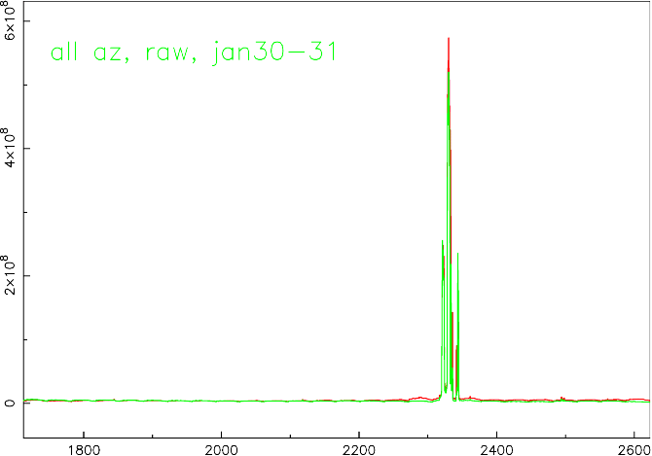

Figure 2: The averaged data of Jan 30: expanded scale.
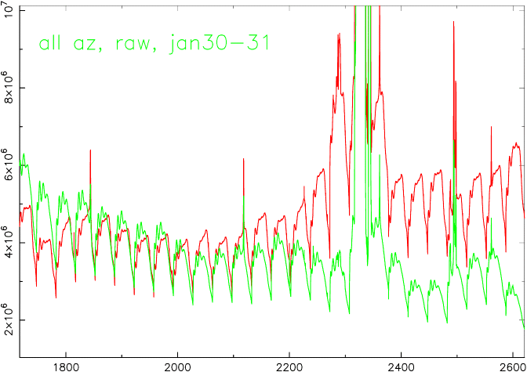
Figure 3: Averaged Raw Spectrum of Feb 8, expanded scale.
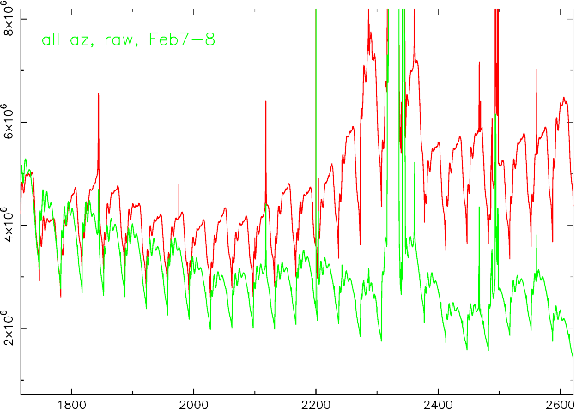

Figure 4A: 1814.6 MHz feature (Jan 30).
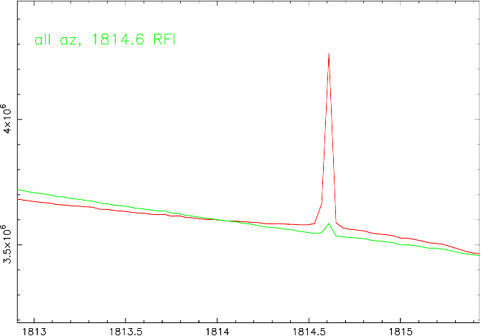

Figure 4B: 1844 MHz feature (Jan 30)
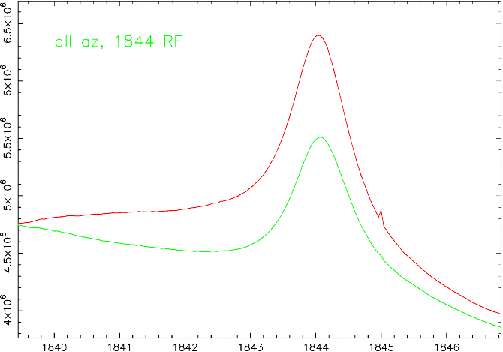

Figure 4C: 2118 MHz feature (Jan 30)
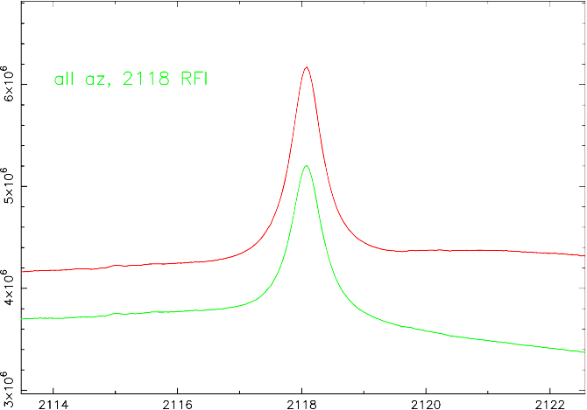
Figure 4D: 2285-2292 MHz features (Jan 30).
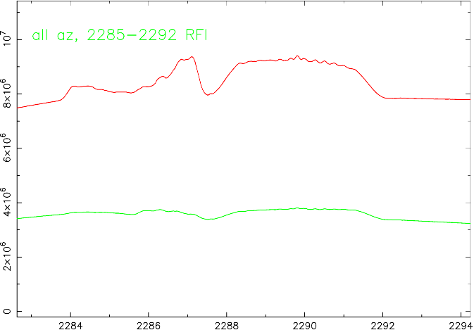

Figure 4E: 2320-2345 MHz (Jan 30).
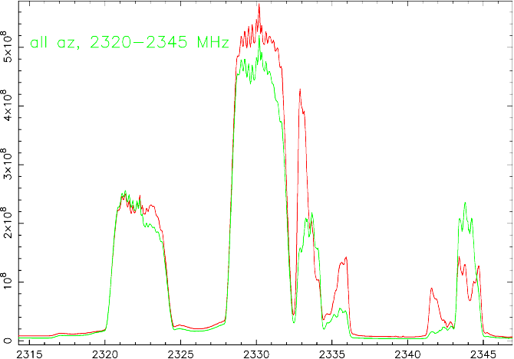
Figure 4F: 2361-2362 MHz (Jan 30)
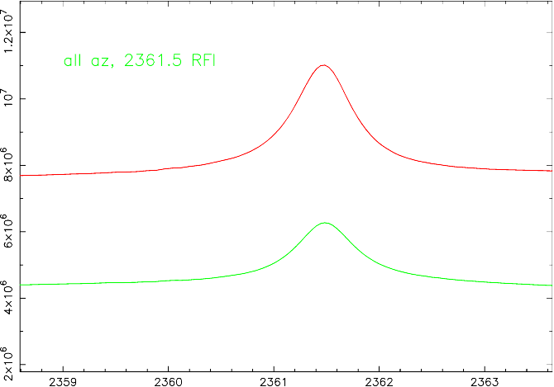

Figure 4G: 2467 MHz (Feb 8)
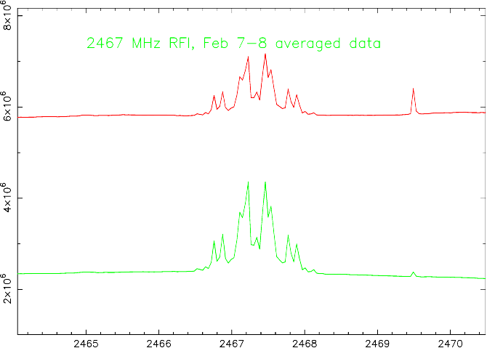

Figure 4H: 2486-2500 MHz (Jan 30).
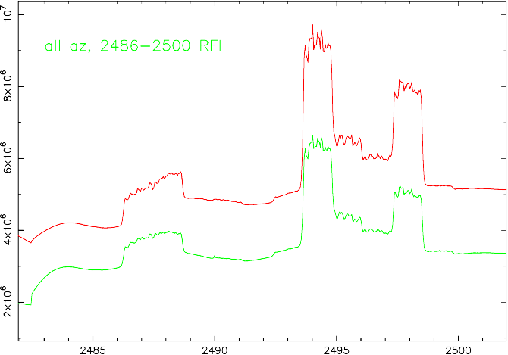

Figure 4I: 2561-2562 MHz (Jan 30)
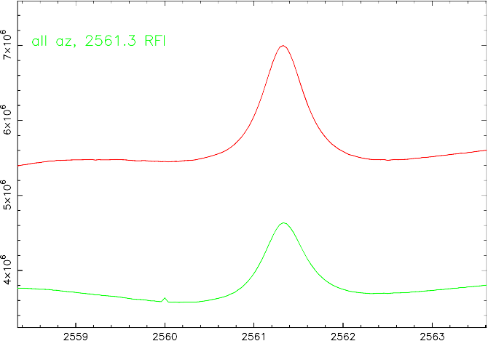

Filtered Spectra
The filtered, baseline-flattened spectra were produced as described above by dividing each spectrum by the median-filtered version of itself. This brings out the narrow band features.
For the Jan 30 session, we show in Figure 5A the filtered spectrum for the X polarization, averaged over all scans; Figure 5B shows the same information for the Y polarization. Note that the spectrum is cleaner for frequencies less than 2200 MHz in the Y polarization.
The list of RFI peaks is given in Table 4. The spectra shown in Figures 5A and 5B are normalized to a baseline of 1.0. Any peaks exceeding 1.002 are listed in Table 4. We have removed all the peaks in the list between frequencies of 2486-2500 and 2317-2346 MHz, all presumably due to satellite RFI. The power (P) in Table 4 is the y-coordinate from the plot (Figures 5A and 5B) transformed to 0.001 units above 1.0; i.e., P = 1000(Y-1), i.e., P is in parts per thousand of the system temperature. The maximum of the 2 polarizations is listed.
For the second session (Feb 7-8), the filtered spectrum is shown in Figure 6. The list of RFI peaks based on the data plotted in Figure 6 is given in Table 5. All peaks exceeding 1.002 are listed in Table 5, omitting those between frequencies of 2485-2500 and 2315-2347 MHz.
Note the channel spacing of 39 kHz for all these spectra means the uncertainty in all the quoted frequencies in these tables is ±0.02 MHz.
Figure 5A: Filtered Spectrum, all directions averaged, Jan 30.
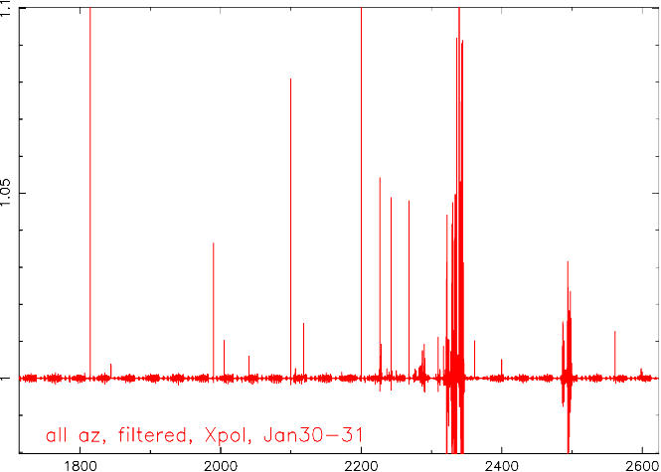

Figure 5B: Filtered data, all directions averaged, Jan 30.
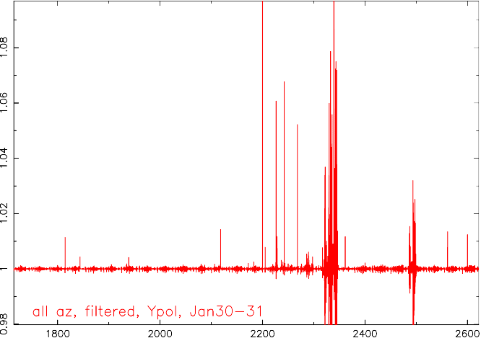

Figure 6: Filtered Data, all directions averaged, Feb 7-8.
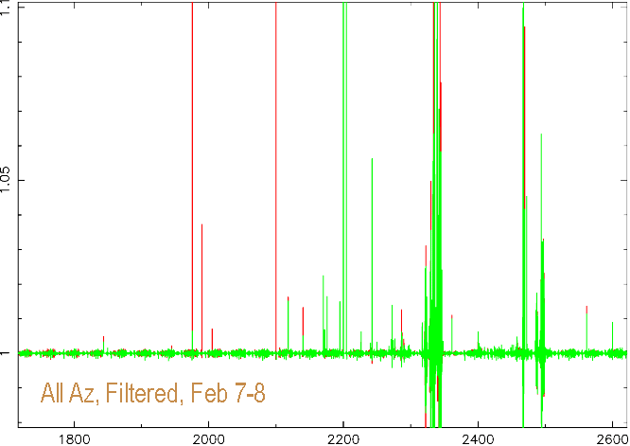
(red is X-polarization, green is Y)

Directional dependences
To look for RFI that may be coming from a particular direction, we have averaged the 2 spectra that were taken at each azimuth pointing and from it subtracted the spectrum averaged over all directions. The difference spectra are given in Figures 7 A-D for the Jan 30 data, and Figures 8 A-D for the Feb 8 data.
In these spectra it is probably best to discount any of the peaks between about 2300 and 2500 MHz as having something to do with one of the satellite RFI signals. Aside from these, we can suspect signals that are large and positive as likely coming from a particular direction.
Looking North (az=6 degrees), there are apparently no significant signals.
Looking East (az=96 degrees), in the general direction of the Jansky lab, there are several significant signals, at frequencies of about 1815, 2200, 2227, and 2244 MHz. The signal at 2200 seems quite significant. In the Feb 8 data, we also see a significant feature at 2467 MHz.
Looking South (az=186 degrees), there are no obvious signals.
Looking West (az=276 degrees), which might include RFI from Snowshow or Cass, there is perhaps one significant signal at 2226 MHz.

Figure 7A: az=06, Jan 30.

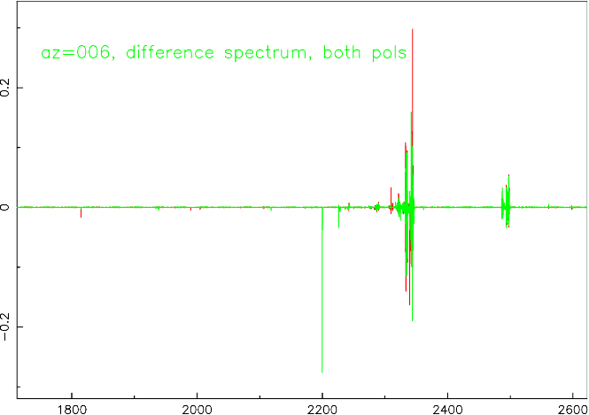

Figure 7B: az=96, Jan 30.

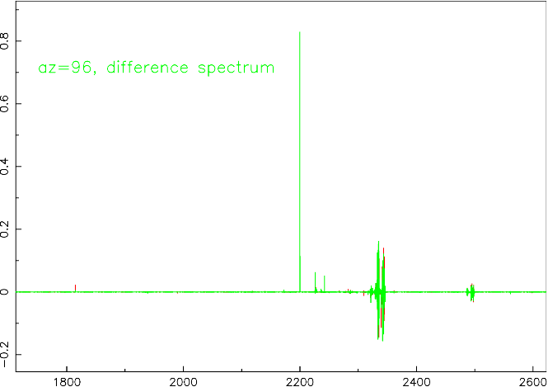

Figure 7C: az=186, Jan 30.

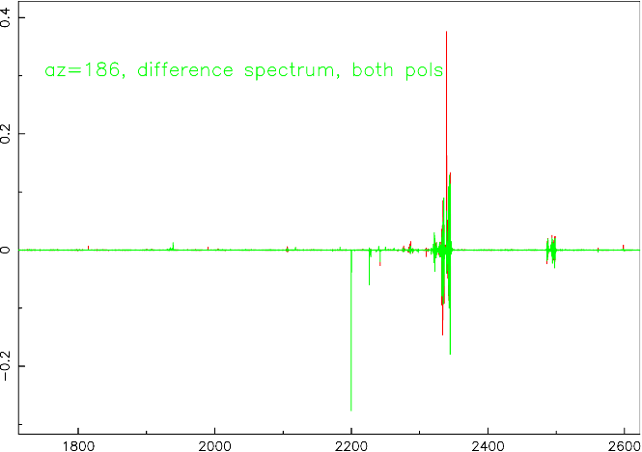

Figure 7D: az=276, Jan 30.

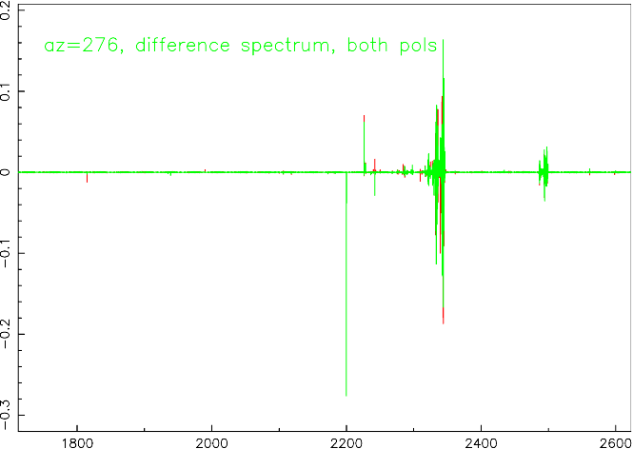

Figure 8A: az=06, Feb 8.

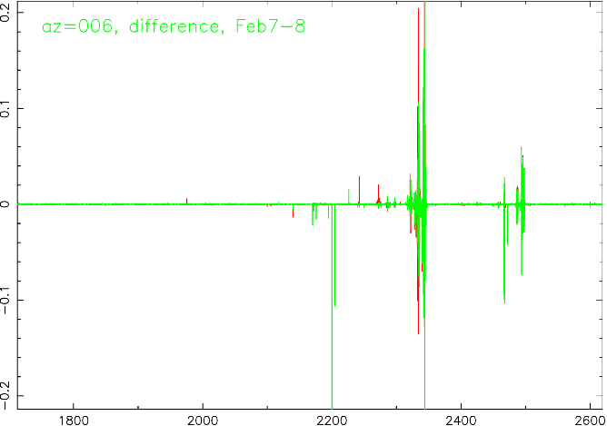

Figure 8B: az=96, Feb 8.

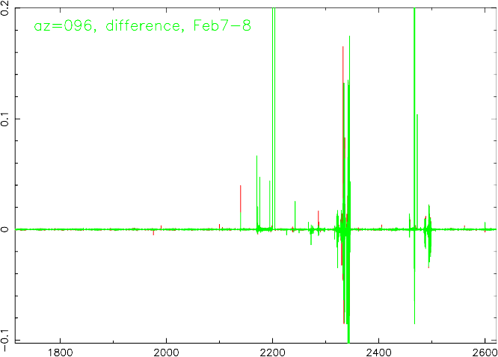

Figure 8C: az=186, Feb 8.

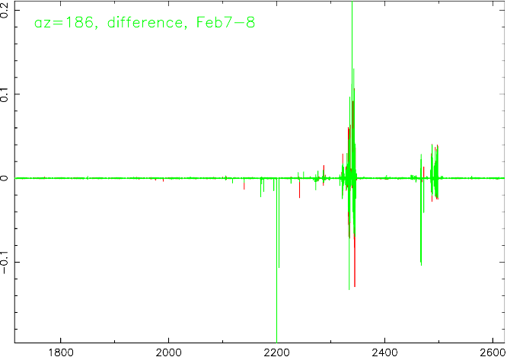

Figure 8D: az=276, Feb 8.

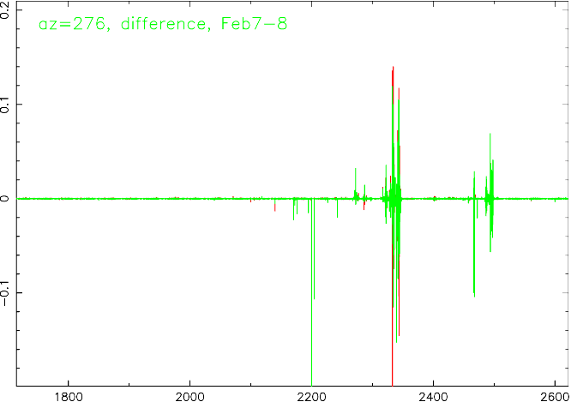

Laser dependent RFI?
To look for differences between the two observing runs, we present the difference between averaged filtered spectra for the Jan 30-31 run and the Feb 7-8 run.
Figure 9A shows this "on-off" spectrum, and Figure 9B shows the same data on an expanded scale. In these plots, the positive-going spikes are signals that were stronger in the Jan 30-31 data, i.e., with the laser systems on. Likewise, the negative-going spikes are the signals that are stronger in the Feb 7-8 data, i.e., with the laser systems off. Inspection of these plots suggests there was more and stronger RFI on the latter date than the former.
We have listed tables of RFI components from the difference spectra. Table 6 lists the components that were stronger on Feb 7-8, and Table 7 lists those stronger on Jan 30-31. Amplitudes are listed in units of 0.001 of the system temp. The tables list all components exceeding 0.002 of the system temp.
There is no clear identification of any of these signals with the laser systems.

Figure 9A; Difference Spectrum: Lasers ON minus Lasers OFF.
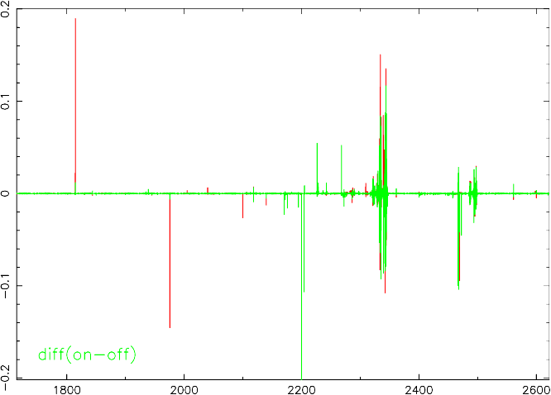

Figure 9B: Difference Spectrum: expanded scale.

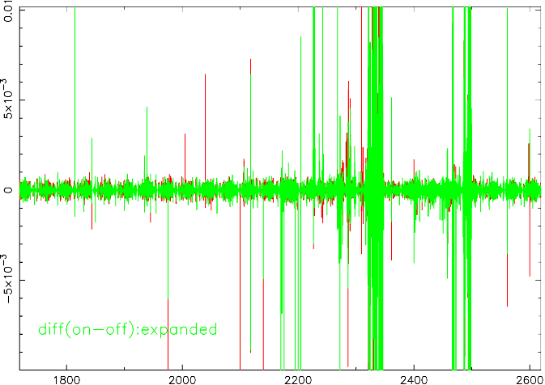

TABLE 4: List of RFI components, Jan 30-31, 2002
P = rfi power relative to baseline in 0.001 units.
W = number of adjacent channels in which RFI
exceeds threshold of P=2
Freq(MHz) | P(milli) | W(chan) | Freq(MHz) | P(milli) | W(chan)
2600.00  2598.40  2598.20  2561.29  2400.00  2361.45  2312.03  2309.61  2309.41  2297.89  2297.70  2290.74  2290.47  2290.23  2289.96  2289.77  2289.61  2289.34  2287.07  2286.72  2286.21  2285.82  2284.14  2284.02  2282.58  2278.44 | 12.4  2.6  2.4  13.4  5.1  11.6  2.4  2.8  11.1  2.2  4.3  2.9  5.3  4.7  2.3  9.2  2.3  3.3  7.5  4.1  5.4  3.4  2.2  3.4  2.9  2.1 | 1  1  1  3  1  3  1  2  3  1  2  2  3  2  2  3  2  2  5  4  5  3  1  2  1  1 | 2276.60  2268.24  2250.00  2243.75  2242.46  2240.00  2236.45  2228.48  2227.50  2226.52  2226.33  2225.82  2205.00  2200.00  2183.20  2118.05  2106.45  2106.37  2100.00  2040.00  2005.00  1990.00  1938.91  1938.83  1844.02  1814.57 | 2.5  52.2  2.1  2.0  67.7  2.4  3.1  11.7  6.3  9.4  60.7  2.4  7.8  276.2  2.4  14.9  2.6  2.2  80.9  5.9  10.2  36.5  2.7  4.1  4.3  189.4 | 1  2  1  1  2  1  1  3  1  1  3  1  1  3  1  3  1  1  1  1  1  1  1  1  3  2

.

TABLE 5: List of RFI components, Feb 7-8, 2002
P = rfi power relative to baseline in 0.001 units.
W = number of adjacent channels in which RFI
exceeds threshold of P=2
Freq(MHz) | P(milli) | W(chan) | Freq(MHz) | P(milli) | W(chan)
2600.00  2561.25  2472.54  2472.46  2469.49  2468.12  2468.01  2467.89  2467.77  2467.54  2467.42  2467.19  2467.11  2466.84  2466.76  2466.64  2466.52  2458.67  2458.55  2458.24  2457.97  2457.66  2457.54  2452.89  2450.27  2434.73  2401.91  2400.00  2361.41  2297.73  2297.54 | 9.0  13.6  38.2  45.4  94.4  14.7  9.5  58.0  103.9  19.7  60.8  63.2  9.7  99.8  92.4  10.5  9.9  3.0  2.9  3.7  2.6  4.7  2.6  2.3  2.5  2.4  2.9  6.2  11.0  2.4  2.2 | 1  3  2  1  2  1  1  2  2  1  2  2  1  2  1  1  1  1  1  3  1  1  1  1  1  1  1  1  4  1  1 | 2290.51  2290.27  2289.80  2287.15  2286.72  2286.25  2285.86  2276.60  2274.18  2272.50  2270.78  2267.50  2250.00  2242.46  2240.00  2226.37  2204.38  2200.00  2194.73  2175.82  2172.23  2170.23  2139.96  2118.01  2100.00  2005.00  1990.00  1975.55  1945.23  1843.98 | 2.2  2.3  4.1  5.9  3.8  12.6  3.7  4.2  3.7  13.9  4.0  2.0  3.2  56.3  3.0  6.2  106.5  2394.2  14.9  16.4  6.8  22.5  13.2  16.3  107.2  7.1  37.3  145.7  2.2  4.9 | 1  1  2  3  2  5  2  2  2  1  2  1  1  2  1  2  2  3  2  2  1  3  2  3  1  1  1  3  1  3

Table 6. List of RFI signals with lasers off (Feb 7-8)

P = rfi power relative to system temp in 0.001 units:
Difference P(Feb 8) minus P(Jan 30).
W = number of adjacent channels in which RFI exceeds
threshold of P=2

Freq(MHz) | P(milli) | W(chan) | Freq(MHz) | P(milli) | W(chan)
2600.00  2561.25  2472.54  2472.46  2469.49  2468.12  2468.01  2467.89  2467.77  2467.54  2467.42  2467.19  2467.11  2466.84  2466.76  2466.64  2466.52  2458.67  2458.55  2458.24  2457.97  2457.66  2457.50  2450.27  2401.91  2400.00 | 4.8  6.5  36.7  45.4  94.5  15.0  9.6  57.8  103.8  18.9  60.4  62.9  9.6  100.0  92.2  10.5  10.0  3.0  2.9  3.7  2.6  4.9  2.6  2.4  2.3  4.0 | 1  2  2  1  2  1  1  2  2  1  2  2  1  2  1  1  1  1  1  2  1  1  2  1  1  1 | 2361.41  2309.53  2289.73  2287.19  2286.60  2286.29  2286.17  2276.60  2274.18  2272.50  2270.78  2270.00  2268.16  2267.50  2226.45  2204.38  2200.00  2194.73  2175.82  2172.23  2170.23  2139.96  2118.01  2100.00  1975.55  1843.98 | 3.9  3.5  2.3  4.1  2.0  9.8  3.2  3.0  3.8  13.9  4.0  2.1  2.1  2.2  3.2  106.5  2252.4  15.0  15.9  6.8  22.4  12.5  9.0  26.3  145.5  2.2 | 2  2  1  2  1  4  1  2  2  1  2  1  1  1  2  2  3  2  2  1  3  2  2  1  3  1

TABLE 7: List of RFI signals with Lasers on (Jan 30-31)

P = rfi power relative to system temp in 0.001 units:
Difference P(Jan 30-31) minus P(Feb 7-8).
W = number of adjacent channels in which RFI exceeds
threshold of P=2

Freq(MHz) | P(milli) | W(chan) | Freq(MHz) | P(milli) | W(chan)
2600.00  2598.40  2598.20  2561.33  2468.05  2467.97  2467.85  2467.66  2467.38  2467.27  2466.95  2466.80  2466.68  2466.60  2458.16  2458.05  2457.58  2361.52  2312.03  2309.61  2309.41  2297.70  2290.74  2290.51  2290.23  2289.80  2289.38 | 3.4  2.6  2.4  10.1  11.4  10.7  12.9  22.4  28.5  18.4  21.8  12.1  9.5  9.3  2.3  2.1  2.2  5.1  2.4  2.8  11.1  2.4  2.4  3.1  2.5  5.1  2.6 | 1  1  1  2  1  1  1  3  1  2  2  1  1  1  1  1  1  1  1  2  3  1  2  2  2  2  1 | 2287.07  2286.80  2286.56  2286.21  2285.86  2285.59  2284.02  2282.58  2272.54  2268.24  2242.50  2236.45  2229.22  2228.48  2227.50  2226.52  2226.33  2225.82  2205.00  2172.30  2118.09  2040.00  2005.00  1938.91  1938.83  1844.10  1814.57 | 6.0  5.6  3.8  3.7  2.9  2.3  3.2  2.7  4.1  52.2  11.4  3.1  2.3  11.3  7.0  8.7  54.5  2.2  8.5  2.2  7.3  6.4  3.1  2.9  4.6  2.9  189.6 | 2  3  1  3  1  1  1  1  2  2  1  1  1  3  1  2  3  1  1  1  2  1  1  1  1  1  2

