Array 2 Cooldown 1 in the Dark
4/11/06

Wirebond/Mux Chip Failures
The nature of 5 detector columns is unknown as wirebond or mux chip failures occurred on cooldown preventing readout of the array. Failures are shown below.

Col 0: open 2nd fb, open 1bias
Col 1: open 2nd fb
Col 2: open detector bias
Col 4: open 2nd fb
Col 7: open 1st fb (possibly in flexpad)

Grounding Issues

A design flaw in the detector package circuit board grounds the board to the dewar at .3K, setting up a ground loop. To mitigate this, two traces must be cut. This was not done prior to array chip installment as intended. The traces will be severed before the next cooldown. It is likely that this ground loop contributed to or even caused all of the excess noise observed.

Detector response

Figure 1 shows a Col 3 multiplexed open loop downwards detector bias ramp with 100
count resolution. Pixels 0,1,3 and 7 show expected SQUID responses with transitions in roughly the same regime. Pixels 4 and 5 clearly have extra resistance in the detector loop as a Ф_{o} of ~10000 counts is observed. There is some transition observed at high bias in these pixels. This behavior has yet to be modeled. Pixels 6 and 8 also show unexplained bias response.

Figure 2 shows a downward detector bias ramp in closed loop on a pixel from column 3.
Due to mapping issues this plot corresponds to the pixel labeled 0 in figure 1.
Extreme amounts of noise are observed on the transition. When locked and appropriately biased, no response to Cal pulse was observed from any pixel in column 3.

Figure 3 shows open loop bias ramps on col 5. The unexplained response seen from pixels 0 and 5 is shown in high resolution in figure 5. This column contains two open detector loops.

Figure 4 displays locked down ramps on column 6. This column contains 8 pixels with transitions in roughly the same place. At least 6 could most likely be biased simultaneously on their transitions. When locked on the transition, extreme amounts of noise and strange oscillations were observed in preamp out. Minimal response to cal was observed.

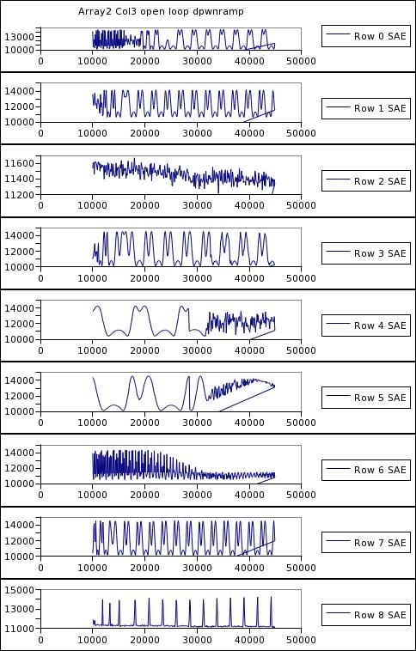
Figure 1. x: detector bias y: SAE

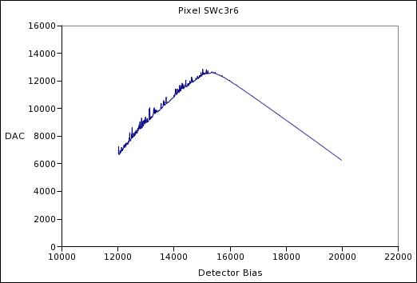
Figure 2

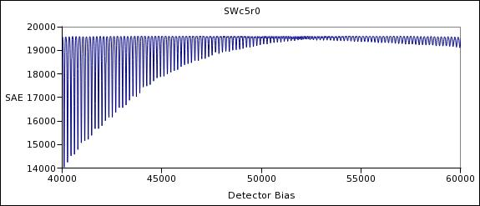
Figure 5

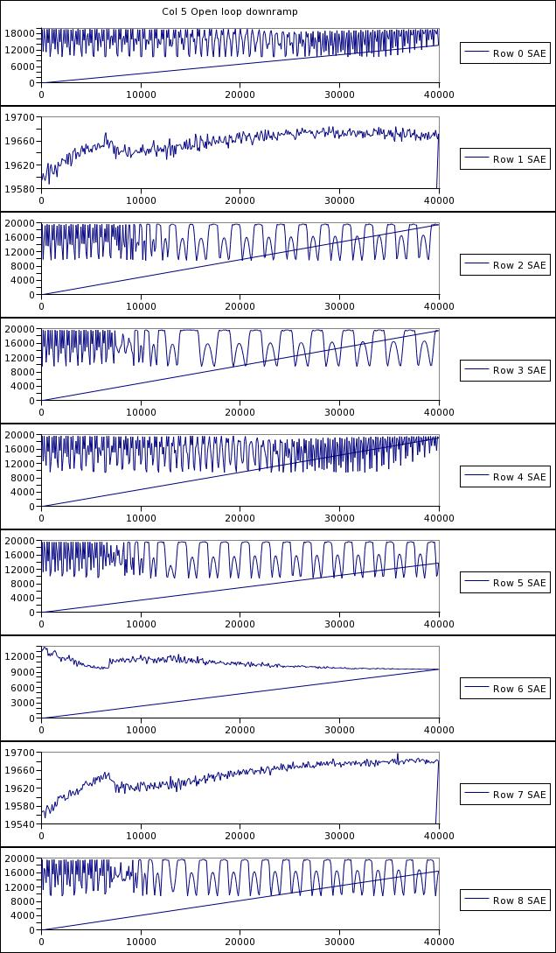

Figure 3: x: detector bias y: SAE

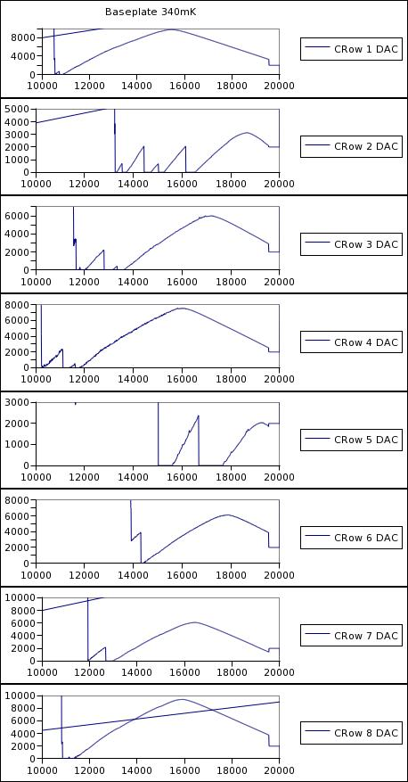
Figure 4: x: detector bias y:DAC

