

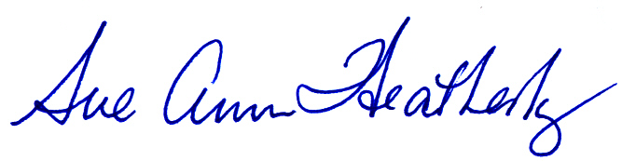

Green Bank Star Quest
certifies that
Jerry Stenton
presented his knowledge of Galileo and his telescope at the 6th annual Green Bank Star Quest event

CErtificate of APPRECIATION
Given this 27th day of June, 2009
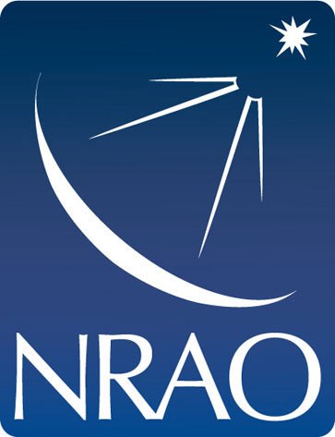

the National RADIO ASTRONOMY OBSERVATORY

