Research Experience for Teachers
The NRAO Research Experience for Teachers Program has been in place since 2000, and with the exception of its duration (the RET program is 8 weeks instead of 10-12 weeks long), the RET program follows the structure of the REU program. A teacher is selected by a scientist, or rarely, an engineer, to work with him/her on a research project. RET teachers participate in many of the REU program activities such as group lectures and field trips. At the end of the summer program, teachers present the results of their research as well as a description of how they might transfer their experience to the classroom.
The current NSF funded program allows for 4 RET teachers each summer, at one or more of the NRAO sites, but we have only rarely reached that cap in a given summer. This can be attributed to 2 factors: the number of applicants for our program is usually small (<15), and the number of scientists willing to mentor a teacher is small as well. Over the entire 11 year history of the RET program, 13 (out of 60?) NRAO staff scientists have mentored a teacher.
In an effort to learn more about obstacles to mentoring teachers in an RET program, we conducted a survey of NRAO scientific staff. (The survey and detailed results are attached at the end of this document.)
Twenty-seven scientists answered the first question on the survey (Have you ever mentored a teacher as part of the RET program?), and twenty scientists went on to respond to additional questions. Of these, 10 scientists had mentored a teacher at least once, and 10 had not.
While the overall response rate was low, some common themes did emerge. Both groups of scientists felt that teachers either lack the skills needed in computational math and physics or that they’re rusty. This, coupled with the shorter length of the program (8 weeks) makes it difficult to complete a research project with teachers. Of scientists who have never mentored an RET, two major obstacles emerged:
- Time: scientists felt they did not have enough time to mentor an RET (8/10 agreed with this statement);
- Information: scientists indicated they did not know enough about the program (6/10 agreed).
It’s evident that NRAO should either reduce the RET effort so that funds requested from NSF will more closely align with expenditures, or restructure the RET program to make it more successful. Reducing the program from 4 to 2 teachers per year seems like a meager solution. So, rather than submit an RET proposal as part of the REU proposal submission due in August, NRAO would prefer to take the time to thoughtfully restructure the program and apply for an RET supplement later this year. From the scientist survey results it does appear that we should be able to recruit more scientists to mentor RET teachers if we make some changes to the program and do a better job of educating our staff about the program.
Note: We could stop herein the proposal if we go this route.

We also have some ideas for restructuring the program that would make it more useful to the teachers who participate, and to NRAO:
- Select research projects that will be more relevant to the teachers’ curricula.
- Allow teachers to come back a second summer to help the new teachers.
- Teachers should work in teams on a research project.
- Create opportunities for teachers to continue their research off-site, and with their students
- Create a community of practice among the teachers by
  - Selecting a larger group each summer ( N=10)
  - Beginning and ending the RET experience as a group
  - Providing time for teachers to collaborate on curriculum development.
The results of an evaluation study conducted of the NSF Division of Engineering RET program (N=898 teachers) corroborate these ideas for improving the NRAO RET program. In surveys conducted of 898 teachers, 3 primary indicators emerged that were key to positive outcome RET outcomes and to teacher satisfaction with the program:
- relevance of the RET program to the subjects teachers taught,
- participation in a variety of activities that included research activities, and
- follow-up interactions.
Participants who worked together on group projects were also more likely to be satisfied with the experience, as they were more likely to be engaged in a variety of research oriented activities. These same three indicators also predicted positive teacher outcomes such as increased teaching capabilities, or new teaching strategies, and student outcomes (Russell, Hancock, 2007).
In addition, NRAO scientists made several suggestions through our survey and in conversations. For example, both groups of scientists indicated that the RET program might be improved (8/10) or that they would be more likely to mentor a teacher (6/10) if community college professors were allowed to apply for RET positions, and if the program could be offered or continued into the school semester (8/10 for veteran RET mentors and 5/10 for the other group).
Taking the time to plan a new program will reap benefits. None of these ideas will work without thoughtful planning and significant input from NRAO scientific staff and from teachers as well.

Reference
Russel, S.H., Hancock, M.P., 2007, Evaluation of the Research Experiences for Teachers (RET) Program: 2001-2006, SRI International, http://www.sri.com/policy/csted/reports/university/documents/RET3_Final_Report_07.pdf (July 20, 2007).
NRAO Scientists RET Survey
- N=27 Have you ever mentored a teacher as part of the RET program?
3: yes, once
8: more than once
16: no
For Those Who Have Mentored a Teacher:
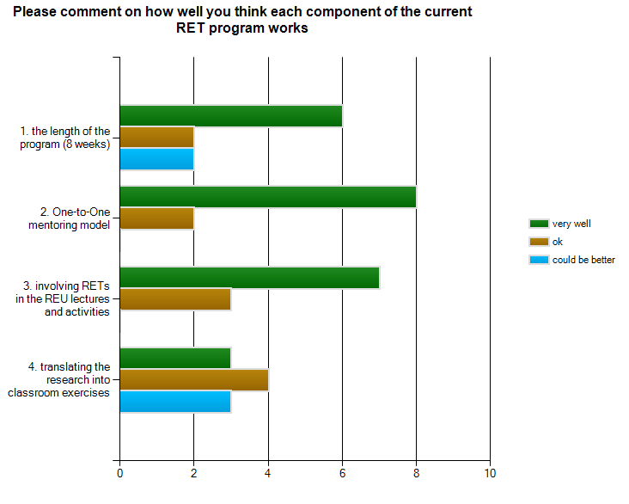
- N=10

Comments:
- The time seems too short. I don't really know how the experience has translated into the classroom. I have not gotten much feedback.
- Eight weeks is often the minimum for a research project that will have noticeable importance. You have to stay on-task the whole time, as opposed to having some freedom to explore side issues. But, how can you have a teacher stay longer than this during their summer off?
- If one of the goals of the RET program is to eventually design classroom activities, this should be made clear to the mentor from the beginning. Perhaps the mentor could help design the research project with that goal in mind. In my case I was not aware of the intention to design classroom activities until well into the summer.
- Is there time for translating the research into classroom activities or do the teachers do this on their own time?
- The length of the program would do better to be 10 weeks, to allow for enough time for the projects to be complete. The majority of the mentors (myself included) have no experience translating science research into classroom exercises, making choosing the correct research project difficult.
- Most of the classroom exercise development was done by the teacher with little interaction with me. Sue Ann was a great help in this area, however.
- I am not a big fan of the structured programs that we run. I realize that I am in the minority, however. Not sure what number 4 means. That is not the main purpose of the program. I see the pgm as a STEM pipeline.
3. When comparing your experience with REUs and RETs, describe any special benefits to mentoring a teacher as opposed to a student.
- Teachers are more mature and have better work habits. While they often are not as current with software they generally spend less time going down unproductive paths. They can work more independently.
- Teachers have better work ethics and more stick-to-it-ness that students. Teachers have broader and more in-depth experiences.
- There are advantages to working with someone with more life experience, if the right kind of research project is available. Social interaction can be better with those who are peers (RETs) rather than students. The benefits of experience can help teachers approach problems in a new way.
- Usually the teacher is older, more mature, with more life experience.
- None.
- Both were excellent. It was nice working with the teacher because she was more mature than the average student.
- not as much of a learning curve.
- Only the "esoteric" benefits, in realizing that the teacher will bring back to the classroom the experience in research and thus perhaps excite his/her students into thinking about a research career.
4. When comparing your experience with REUs and RETs, describe any special drawbacks to mentoring a teacher as opposed to a student.
- The teachers can have limited experience with modern computer systems. They may not be as current on astronomy as the students.
- The candidate pool for teachers is rather narrow. Depending upon the research topic, a teacher's background may be a bit staler than that of a student and so some time at the start is spent bringing the teacher back to speed. But, usually, after that the teacher's progress often becomes faster than that of a student.
- Teachers tend to have fewer technical skills and a longer learning curve to come up to speed on computing issues.
- The teachers background is not the experience that need to do the work. Time must be spent bringing their skill set up to the appropriate level.
- Teachers can be far more opinionated (both good and bad) and far more difficult to motivate.
- One nice thing about the REU mentoring is seeing your student advance on to graduate school and then into a professional astronomer. That connection is missing with the teachers, but there are still some nice future interactions.
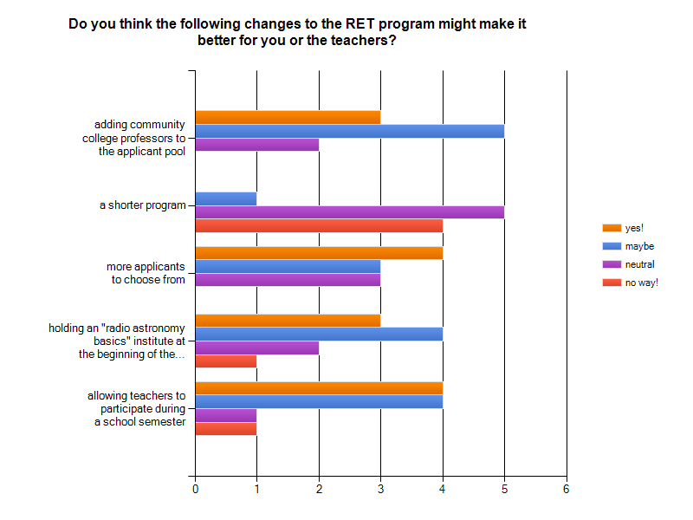
- There are some drawbacks. In general, the teachers have not been doing research, nor have they been doing coursework (e.g. mathematics, science) which the undergraduates have. Thus it takes them longer to "get up to speed" or they may never quite understand the nuances of the research that is being taught/done. Undergraduates, already in a learning environment, usually don't have this problem. Undergraduates, being younger, usually show more overt interest and excitement; one sometimes has to draw this out of the teachers.
5. N=10

- It makes sense to have the RET experience extend outside of the summer residential program. They easily could (and some have) continue work throughout the school year as a real collaborator.
- I really liked your idea of sending teachers to NSTA. A small minority of projects might still be better advertised at the AAS -- or the Socorro mentors might not appreciate that NSTA is a better forum than AAS. Also, may want the AAS if, in that year, the AAS is partnering their meeting with another entity like AAPT. Maybe also require that each teacher write an article for something like one of the NSTA magazines?
- 25% of my time was dedicated to the RET when I participated. 75% of my time can be used for observatory work of which I could dedicate 25% to an RET however during this time of commissioning for the EVLA I simply do not have the time to have an REU or an RET.
- I've never really understood the purpose or importance of the RET program in terms of NRAO or NSF's mission.

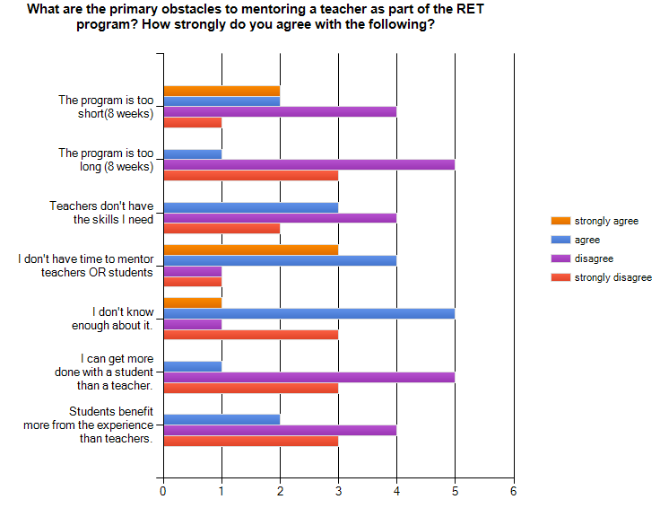
For those who have Not mentored a Teacher:
2. N=10

Other obstacles? Please list:
- I have the feeling that mentoring a student would be perceived as a stronger item on my CV than mentoring a teacher (unintentionally, perhaps, but nevertheless...)
- I have not mentored a teacher, mostly due to lack of time and a skepticism that they'll have the right skills. An 8 wk terms seems about right to me - maybe even 10-12 weeks if we can break it up into several visits. The profile of the RET program has generally been fairly low within the Observatory.
- With students we have a significant fraction that go on to astronomy (or other science fields). There is an obvious, positive, long term impact for the observation and for science. With teachers the longer term impact is not so obvious. I know it is there is an impact - the teachers get their students interested and then some of the students eventually become scientists and we should be getting a more science literate public.
- Its been a while, but if memory serves, the recruitment was a major issue - the RET applications were not available at the same time as the REU, or were somehow lacking. If they can be considered at the same time as when staff are reviewing REU candidates, I suspect more might be selected. But the 8 week thing is a drawback. Isn't a good chunk of that also taken up by curriculum development activities?
- Not offered in CV.
- While a Ph.D. Astronomer, my current skill sets and expertise is heavily on the computing side of things.

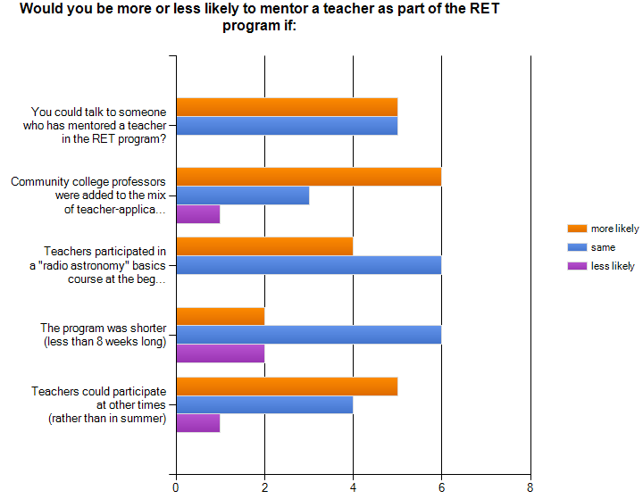
- N=10

Other ideas?
- I think these are all good ideas. It would also be helpful to expand the pool of applicants through broader advertising.
- The astronomy course is a good idea but I think it would be beneficial if it was before/outside the 8 weeks the teachers are available. If you had teachers here for 6 months to a year could they be 50% working on research and 50% helping the educational programs in some fashion? If you came up with something that could be sold to school boards then they would be more likely to give a 6 month or year sabbatical to a teacher if they were to gain something from it.
- See recruitment above.

- Please use this space to add any other thoughts about the RET program.
- The main barrier I personally have to mentoring students or teachers is *time*. I currently have one grad student and would be hard pressed to take on anyone else.
- I have never understood the purpose and priority of the RET program from NRAO or NSF's perspective. I think I understand the REU pgm.

