A Note on a Possible Explanation of GBT S-Band Receiver Baseline Variability

Marian W. Pospieszalski

28 January 2003

- Introduction

This short note is to suggest a possible explanation of the baseline variation observed in GBT S-band receiver as reported by Rick Fisher in his memorandum titled “Second Baseline Test of the 2-3 GHz GBT receiver “[1] dated Dec.2, 2003.

The results presented here are not based on any actual measurement of the components of the receiver but only on reasonable assumptions concerning receiver behavior. Therefore, these results only point to a possible line of inquiry that would explain the measured results.

- Discussion of Measured Results

Fig 11 of [1] presents the plots of ratio (T_{on}-T_{off})/T_{off} versus sky frequency from 1.89 GHz to 2.09 GHz. There are two dominant features in that plot for channel 1. One is a steady decrease in the ratio from about .58 to about .53 with increasing frequency. The other is a sinusoid like variation with about 120 MHz separations between the peaks and the peak-to-peak variation of about .03. We shall discuses here only a possible explanation for the second pattern, although both pattern could be caused by similar phenomena.
It is reasonable to assume the difference in the sky noise in on and off positions not being dependent on the sky frequency in such a narrow frequency range. Consequently, the observed change in the ratio can only be explained by the variation in the system noise temperature T_{off}. Assuming the average system noise of 20 K, the peak–to-peak changes of 1.1 K (.03*20/.555) would explain the observed pattern. It is likely therefore the changes in the receiver noise temperature as referred to the input of the horn are the cause of the observed pattern. A possible explanation for this effect is offered in the next section.

3. Receiver Model

The S-band receiver does not employ isolator between the cryogenic amplifier and OMT. The amplifier is connected directly to the OMT, which in turn is connected to the horn. The question is how big of a discontinuity and how far from the amplifier input could cause the noise temperature variations with values changing by about 1.1 K for frequencies separated by 120 MHz. For the development of a good noise model of the receiver the knowledge of the input return loss (IRL) of the OMT connected to the horn is not sufficient as the location of the discontinuities causing a particular pattern in the IRL is important. Also the knowledge of the amplifier noise temperature is not sufficient as the knowledge of all four noise parameters of the amplifier as a function of frequency is needed. The purpose of this note is only to show that indeed an interaction of the amplifier and discontinuities in the horn-OMT assembly can in principle produce the observed patterns.
The gain, noise temperature and input return exhibited by a test design of 1.9 to 3.1 GHz cryogenic amplifier using commercial HFET’s is shown in Fig.1. The noise temperature of this design in 1.89 GHz to 2.09 GHz is indeed very flat as shown in Fig. 2. The noise temperature of the same amplifier disturbed by a small capacitive discontinuity producing about 20 dB ORL (as seen at amplifier input) placed 44 inches away from amplifier is also plotted in plotted in Fig.2. The schematic of this fictitious arrangement is shown in Fig.3. This small discontinuity, even in absence of any ohmic losses will produce a noise temperature pattern consistent with the one needed for an explanation of the pattern in the baseline.

- Discussion.

It should be stressed again that the explanation of one of the patterns in the baseline is based on a fictitious model. A simple test whether the described scenario offers a plausible explanation for this particular receiver would be to measure the receiver noise temperature variation over similar bandwidth with sufficiently small IF bandwidth. Due to the size of the horn it may be a difficult task. Creating a good model would require the knowledge of four noise parameter of the amplifiers and the two–port parameters of the horn–OMT assembly. By the latter it is understood that one port should be defined at some reference plane in front of the horn for one polarization and the other at one of the outputs of the OMT. If there exist a dominant reflection in the horn-OMT assembly and the location of the cause of this reflection is known then again with the knowledge of four noise parameters of the amplifiers a good model can likely be developed. Certainly, the use of an isolator or balanced amplifier instead of an unbalanced version would in principle greatly reduce the sensitivity of the receiver noise temperature to residual reflections at the input [2], [3].

4. References

1.Rick Fisher “Second Baseline Test of the 2-3 GHz GBT receiver “ Memorandum dated Dec.2, 2003.
2. M. W. Pospieszalski, "On the Noise Parameters of Isolator and Receiver with Isolator at the Input," IEEE Trans. Microwave Theory & Tech., vol. MTT-34, pp. 451-453, April 1986.
3. A.R. Kerr, “On the Noise Properties of Balanced Amplifiers”, IEEE Microwave and Guided Wave Letters, Vol. MGWL-8, pp.390-392, November 1998

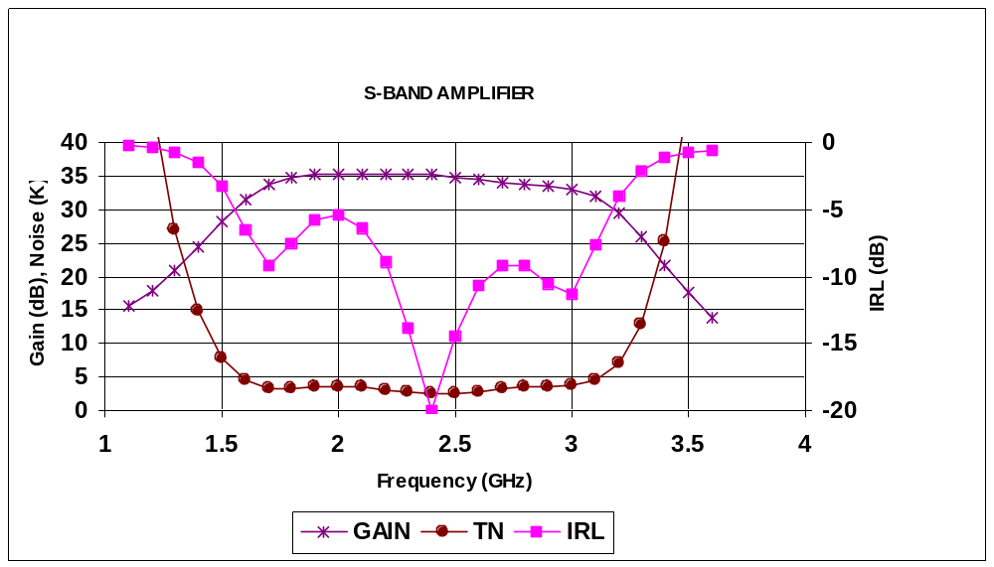
Fig. 1. Gain, noise temperature and input return exhibited by a test design of 1.9 to 3.1 GHz cryogenic amplifier using commercial HFET’s.
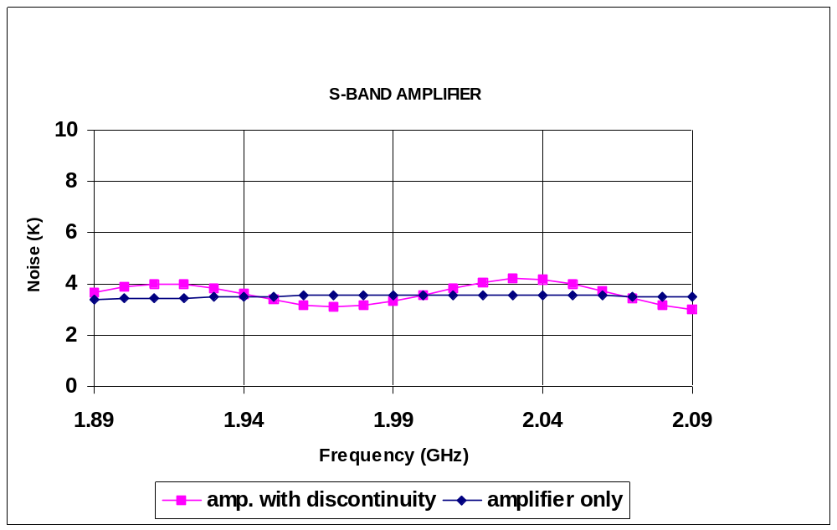Fig.2. Noise temperature of the design of Fig.1 in 1.89 GHz to 2.09 GHz frequency range with and without a small capacitive discontinuity placed 44 inches (in air) away from the amplifier as shown in Fig 3.

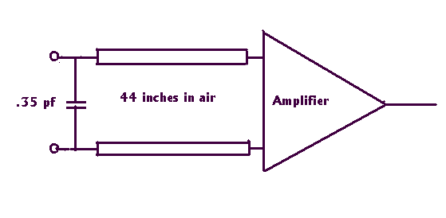
Fig.3 Schematic of the amplifier with capacitive discontinuity, which produces a pattern in noise temperature as shown in Fig 2. The characteristic impedance of the line connecting .35 pF capacitor with the amplifier is 50 ohms.

